

**Major project part-II report on**

**Smart Wearable Technology: Smart-Glass**

**Submitted in partial fulfillment of the requirements for the degree of**

**B. Tech**

**Electronics and Telecommunication Engineering**

**By**

|  |  |  |
| --- | --- | --- |
| **AYUSH DEV**  **SHUBHAM SAXENA**  **SIDDHANT PANDEY**  **SOURAV DAS** | **1804160**  **1804199**  **1804200**  **1804206** |  |

**Under the guidance of**

**Prof. (Dr.) NIRMAL KUMAR ROUT**

**School of Electronics Engineering**

**KALINGA INSTITUTE OF INDUSTRIAL TECHNOLOGY**

**BHUBANESWAR**

**12th April, 2022**

**CERTIFICATE**

**This is to certify that the project report entitled “SMART WEARABLE TECHNOLOGY: SMART-GLASS” submitted by**

|  |  |
| --- | --- |
| **AYUSH DEV**  **SHUBHAM SAXENA**  **SIDDHANT PANDEY**  **SOURAV DAS** | **1804160**  **1804199**  **1804200**  **1804206** |

**In partial fulfillment of the requirements for the award of the Degree of Bachelor of Technology in Electronics and Telecommunication Engineering is a bonafide record of the work carried out under my(our) guidance and supervision at the School of Electronics Engineering, KIIT (Deemed to be University).**

**(Signature of Supervisor 1)**

**Prof. (Dr.) Nirmal Kumar Rout**

**School of Electronics Engineering**

**KIIT (Deemed to be University**

|  |  |
| --- | --- |
| **The Project was evaluated by us on _____________**  **EXAMINER 1 EXAMINER 2**  **EXAMINER 3 EXAMINER 4** |  |
| **ACKNOWLEDGEMENTS**  **We feel immense pleasure and feel privileged in expressing our deepest and most sincere gratitude to our supervisor Professor (Dr.) Nirmal Kumar Rout, for his excellent guidance throughout our project work. His kindness, dedication, hard work and attention to detail have been a great inspiration to us. Our heartfelt thanks to you sir for the unlimited support and patience shown to us. We would particularly like to thank him for all his help in patiently and carefully correcting all our manuscripts.**   |  |  |  | | --- | --- | --- | | **Roll Number** | **Name** | **Signature** | | **1804160** | **AYUSH DEV** | **WhatsApp Image 2022-04-07 at 8.54.11 PM** | | **1804199** | **SHUBHAM SAXENA** |  | | **1804200** | **SIDDHANT PANDEY** | **WhatsApp Image 2022-04-07 at 9.13.54 PM** | | **1804206** | **SOURAV DAS** |  |   **Date:- 12/04/2022** |  |

**ABSTRACT**

*Study on developing Smart wearable technology is taking its boom in recent years making efforts towards better human life. Smart Wearable Technology typically refers to the use of information and communication technology in parallel to the hardware components. Prime examples of Smart Wearable Technologies are Smart Glasses and Smart Watches. The integration of smart wearables with human well-being is becoming reality these days. Some of the leading companies like Google, Microsoft, and Facebook also jumped into this field and are achieving advancements in this concept of smart wearables. The research work is also accelerating in this field day by day.*

*The wearable technology that we are developing is the integration of smart glass and smart watch using IoT, embedded systems, machine learning, and several other supporting technologies with human life for increasing efficiency, productivity, and to interlink computing devices into our everyday life. This system is capable of handling a large variety of computing activities that an ordinary human cannot do. It also comes with the luxury of a modern, compact and comfortable design to wear. Smart Glasses can also be useful for visually and hearing-impaired people. It can be basic support for these kinds of people. For blinds, several solutions are already available but they lack some functionalities and ease of use. In this paper, we are trying to rectify those problems.*

*Smart glasses are equipped with a transparent optical display, which is placed in the line of sight without marginally obstructing human vision. It will be equipped with a touchpad allowing the users to control the device by swiping through a timeline-like interface displayed on the optical display. Interaction between user and glass will also be taken care of by using a voice assistant. It will have the capability of capturing photos and videos on the go.*

*By developing and providing this system at a lower price to the people of India will also assist “Digital India”.*

**TABLE OF CONTENTS**

**Abstract 4**

**Table of Contents 5**

**List of Figures 8**

**List of Tables 11**

**List of symbols/ abbreviations 12**

**CHAPTER I: INTRODUCTION 13**

* 1. **Background 13**
  2. **Applications 13**
  3. **Scope in the real world 13**

**CHAPTER 2: LITERATURE REVIEW 14**

**CHAPTER 3: Technology Used 18**

**3.1.**  **ESP 32 cam 18**

**3.2 Display 18**

**3.3 Speaker and microphone 18**

**3.4 MPU 6050 19**

**3.5 Eye blink sensor 19**

**3.6 Vibrator 19**

**3.7 Machine Learning 19**

**3.8 WIT AI 20**

**3.9 MAX30100 20**

**3.10 Power source 20**

**3.11 Application 21**

**3.12 Storage 21**

**3.13 Power management 21**

**CHAPTER 4: PROPOSED MODEL 22**

**4.1 Data acquirement 22**

**4.1.1 Temperature 22**

**4.1.2. Movement tracking 22**

**4.1.3. Distance and obstacle detect 22**

**4.1.4. Image and video capture 23**

**4.1.5. Blood O2 and Heart Rate 23**

**4.1.6. Capacitive touch 23**

**4.1.7. Eye blink detector sensor 24**

**4.1.8. Design and connection of sensors, actuators 24**

**4.2. Data processing 24**

**4.2.1. Data receiving from sensors 25**

**4.2.2. Image processing and object/text/person detection 25**

**4.2.3. Wit Ai implementation 30**

**4.2.4. Sound conversion from speech to text 33**

**4.2.5. Mobile application 34**

**4.3. Data storage 39**

**4.4. Data transmission 39**

**4.5. Special functions 40**

**4.5.1. Google Search 40**

**4.5.2. Gesture control 41**

***4.5.3.* Entertainment 41**

**4.6. Power and power management 41**

**CHAPTER 5: RESULTS AND DISCUSSION 43**

**5.1 Object detect using esp32 cam 43**

**5.2 FTP connection with application 46**

**5.3 Displaying results on web-page 49**

**5.4 Speech to text output 50**

**5.5 Person & Object Detection 50**

**5.6. Temperature and steps output 52**

**5.7. Android Application UI 53**

**5.8 Android Application Results 56**

**CHAPTER 6: SOCIO-ECONOMICS ISSUES 62**

**6.1. Cost Analysis/Budget 62**

**6.2. Safety analysis 63**

**6.3. Global impact 63**

**6.4. Lifelong Learning 64**

**6.5 Sustainability 64**

**6.6 Ethical Issues  65**

**6.7 Tools and Standards 66**

**6.8 Constraints 66**

**CHAPTER 7: CONCLUSION 67**

**PLANNING AND PROJECT MANAGEMENT 68**

**REFERENCES 69**

**Appendix A: Gantt Chart 71**

**Appendix B: Project Summary 72**

**LIST OF FIGURES**

|  |  |  |
| --- | --- | --- |
| **Fig no.** | **Description** | **Page No.** |
| **1**  **2**  **3**  **4**  **5**  **6**  **7**  **8**  **9**  **10**  **11**  **12**  **13**  **14**  **15**  **16** | **Block diagram of SmartGlass**  **SSD MobileNet flow diagram**  **Block Diagram of Yolov4**  **Yolov4 Implementation using live camera feed**  **Flowchart of Wit AI implementation**  **Training of Application in Wit AI choice of intent**  **Training of Application in Wit AI choice of utterance**  **Training of Application in Wit AI addition of Trait**  **Training of Application in Wit AI validating the application**  **Text to speech conversion**  **Block diagram of the android application**  **File transfer between smart-glass and mobile using FTP**  **Audio transfer between smart-glass and mobile using Bluetooth**  **Online image and video processing and storing**  **Output at Serial Monitor**  **Mobile File manager app showing data from ESP32 SD card over FTP** | **25**  **27**  **28**  **29**  **30**  **31**  **32**  **32**  **33**  **34**  **35**  **39**  **39**  **40**  **46**  **47** |
| **17** | **Browsing Image taken by ESP32 on android image viewer** | **47** |
| **18** | **Arduino IDE serial monitor, showing content files and their sharing over FTP protocol** | **48** |
| **19** | **Webpage displaying the predicted object/person results** | **49** |
| **20** | **Webpage displaying the predicted results of random image taken** | **49** |
| **21** | **Webpage displaying the predicted results from image of a part of laptop** | **50** |
| **22** | **Speech to text ML model output** | **50** |
| **23** | **Image as Input using SSD mobilenetv4 and scaled-yolov4** | **51** |
| **24**  **25**  **26**  **27**  **28**  **29**  **30**  **31**  **32**  **33**  **34** | **Object detection using Capturing using camera**  **Object detection using live camera feed**  **Calculated steps and body temp output from MPU6050 sensor**  **Layout and Code Snippet of the Main Interface**  **Layout and Code snippet of the Object Detection Interface**  **Layout and Code snippet of object info thread Control Interface**  **Layout and Code Snippet of Reminder  List Interface**  **Layout and Code Snippet of the Task Completion Interface**  **Layout of the Home Screen**  **Layout of the To Do List**  **Layout of the To Do List (No Activity)** | **51**  **52**  **52**  **53**  **54**  **54**  **51**  **55**  **56**  **56**  **57** |
| **35**  **36**  **37**  **38**  **39**  **40**  **42**  **43** | **Layout of the Object detection interface**  **Layout of the Object Detection with thread control**  **Layout of the Object Detection with thread control (6 threads)**  **Layout of the browser interface with Maps**  **Layout of the browser interface (Empty)**  **Layout of the Bluetooth Connection Interface (BT off)**  **Layout of the Bluetooth Connection Interface (BT on)**  **Gantt Chart** | **57**  **58**  **58**  **59**  **59**  **60**  **60**  71 |

**LIST OF TABLES**

|  |  |  |
| --- | --- | --- |
| **Table ID** | **Table Title** | **page** |
| **1.**  **2.**  **3.** | **Comparison between all states of ESP32 CAM**  **Cost analysis table**  **Showing details about project planning and management** | **42**  **62**  **68** |
|  |  |  |
|  |  |  |

**LIST OF SYMBOLS / ABBREVIATIONS**

|  |  |
| --- | --- |
| **°** | **Degree Symbol** |
| **μ** | **Micro (10 -6)** |
| **m** | **Milli (10 -3)** |
| **k** | **Kilo (10 3)** |
| **V** | **Volt** |
| **A** | **Ampere** |
| **W** | **Watt** |
| **IoT** | **Internet of Things** |
| **I2C** | **Inter-Integrated Circuit Communication** |
| **SPI** | **Serial Peripheral Interface** |
| **UART** | **Universal Asynchronous Receiver Transmitter** |
| **MCU** | **Micro Controller Unit** |
| **C** | **Centigrade** |
| **SD** | **Secure Digital** |
| **HTTP** | **Hypertext Transfer Protocol** |
| **ML** | **Machine Learning** |
| **AI** | **Artificial Intelligence** |
| **LCD** | **Liquid Crystal Display** |
| **FTP** | **File Transfer Protocol** |
| **CNN** | **Convolutional Neural Network** |
| **API** | **Application Programming Interface** |
|  |  |

**CHAPTER 1**

**INTRODUCTION**

**____________________________________________________**

* 1. **Background**

The pace at which the technology sector is rising is enormous because of its widespread all over the world and with constant improvements in its services and quality. The research on developing smart technology has grown rapidly in recent years in contributing towards a smart and enhanced human life [1]. The term smart innovations specify the employment of hardware, software, integration in a very efficient and innovative manner. Smart wearables, such as smart glasses, smart jackets, smart textiles, fashion accessories, such as smart jackets, smart hats, and gaming gadgets, are among the most commonly utilized items in today's technology [2]. The wearable technology that is proposed, is the integration of smart glass and smartwatch using IoT, embedded systems and machine learning technologies with human life for increasing efficiency, productivity, and interlinking computing devices into our everyday life*.* This system is capable of doing a wide range of computer tasks that a normal human cannot. It also has the added benefit of being stylish, small, and pleasant to wear. Smart Glasses can also help those who are visually or hearing challenged. It can provide minimal assistance to these individuals. Several solutions for blinds are currently available, however, they lack some features and are difficult to operate. The proposed solution is attempting to address such issues in this paper.

**1.2 Applications**

These technologies have lately expanded in multiple regions, specifically the industrial areas, gaming, and pharmaceutical sectors in fixing real-life problems because of their portability, flexibility, and functionalities. The problem is the need for real-time requirements of huge data, processing, and forecasting in completing the tasks. Considering recent inventions, smart glasses can also be called multi-function glasses with the efficiency of handling a broad variety of tasks that a normal human is unable to. They are wearable glasses that add many other useful information alongside what the user observes.

**1.3 Scope in the Real World**

As the world is moving towards a microscopic era and devices are getting smaller and smaller like, the fabrication process used in processors in 2017 was 28nm whereas in 2021 is 5nm [3], so a small and portable device capable of making calls and messages, taking pictures and videos, and capable of doing many other tasks will be remarkable. The proposed solution along with normal people will also ease the life of blind people. According to the knowledge, these smart devices tend to have some specific functions helping in reducing human effort.

**CHAPTER 2**

**LITERATURE REVIEW**

**____________________________________________________**

There is a lot of research and development going on in the field of smart wearables and also in the field of smart glasses. There are many ideas and technologies that have been introduced for smart glasses in recent times, some of them are gesture controls, eye tracking, augmented reality, transparent display, etc [4]. The smart glasses have found their applications in various fields like defence, medical, education, as an assistant, etc [5].

In the present scenario, there are several smart glass technologies which are from Google, Epson, Meta-Pro,Oculus Rift Vuzix, etc. are existing and various research papers have been published mainly focusing on productivity.

Looking at Google glass, it came to the market around 2014 with a 5-megapixel camera that can record videos up to 720p resolution. To control or to interface the glass, a touchpad on the sidebar of the glass is present. The 2014 version of the Google glass consists of features like weather notification, event reminder, taking and viewing photos, also the updates from mobile phones, and it can also handle phone calls which is one of the best features. Google has also released improved versions in 2017 and 2019 the latest version of google glass, enterprise edition 2 has a better AR experience with improved battery and processing power with increased RAM and storage capacity, but the availability and the pricing is an issue with these glasses [6].

Coming to Oculus Rift it was launched as a virtual reality solution which used two displays in front of lenses close to the eyes of the wearer. There is one display in front of each eye, together having a 1920 X 1080 pixel resolution on the latter models. Oculus rift tracks head movement using infrared LEDs but also relying on gyroscope and accelerometer. The advantage of this was that it provided very low latency but the advantages were overshadowed by its disadvantages like over time errors accumulate and there might be an orientation drift. Also Many users experienced a series of problems with the early prototypes of the Oculus Rift. Furthermore, even the newest Oculus Rift prototypes weigh around 0.5 kg which is not very comfortable for the user. [7]

Vuzix has also developed blade smart glasses somewhat similar to google glass these glasses includes an 8-megapixel camera that is capable of recording 1080p video, stereo speakers, noise cancellation microphones, head movement tracker, touchpad with gestures, expandable storage it has a see-through or transparent display which is different from google glasses [8].

In the current situation of market,the barriers that can he crossed by the smart glass providers are stated as mentioned below [9] :

* **Hardware Boundaries:** Processors for Augmented Reality-enabling tasks are steadily improving, but matching required capabilities for enterprise with optimal form factors is still a challenge. A high-resolution front-facing camera is necessary for creating Augmented Reality experiences but not all smart glasses have that functionality. Tilting and shaking also present challenges for both AR experience delivery and video conferencing.
* **Network Security and Bandwidth Required:** The devices are hungry for internet connectivity nowadays for better connectivity. Ensuring reliable WiFi availability in all areas is not possible.
* **User Experience** A smooth user experience is still a challenge for the smart glass providers. How to best interact naturally with the displayed content is something all manufacturers are trying to solve. Bulkiness,ease of access and limited field of view are also some other additional complaints that are still prominent.

Now going through the previously published papers and book chapters, a chapter of Proceedings of International Joint Conference on Computational Intelligence named Microprocessor-Based Smart Blind Glass System for Visually Impaired People [10] has proposed the model for visually impaired people to assist them for walking by alerting them about the obstacle in front of them using ultrasonic sensor and camera. But this system has some flaws which are as follows:

* Only detects the obstacle in front of blind person but what if any person or animal or vehicle is rushing towards him from back or sideways then the person will not be able to know what is heading towards him until it collides with him.
* Use of raspberry pi makes the whole system too costly for the common masses and raspberry pi is also under-utilized in this proposed model.

It is very important to make the interfacing of the smart glass seamless and hands-free to provide the best user experience [11], for this some of the technologies are developed and on some of the technologies the research is going on like gestures, eye tracking, head movement tracking, etc [12].

The proposed solution aims at providing the most of the features of various discussed smart glasses which are relevant and useful in day to day activities and some additional features as assistance for blind people.

Proposed solution provides:

* Object detection with a voice output to the user corresponding to the object
* Obstacle avoidance assistance for blinds
* Text/sign to speech
* Photo and video recording
* Navigation assistance
* Activity Tracking
* Notifications from various mobile apps etc.

**CHAPTER 3**

**TECHNOLOGY USED**

**____________________________________________________**

In this paper, for implementing the proposed device, the required technologies are described in this section.

**3.1.** **ESP 32 cam :**

ESP32-CAM is a low-power 32-bit development board that we are using for our application. ESP32-CAM is the smallest Wi-Fi SoC with an onboard camera and some of its versions also have Bluetooth. This board supports OV2640 and OV7670 camera modules with resolutions of 2MP and 0.3MP respectively. ESP32-CAM has a clock speed of up to 160MHz and a built-in 520 KB SRAM [10]. Communication protocols available on this board are UART, SPI, I2C. Different Operating modes of ESP32-CAM are station mode (STA), access point (AP), both station and access point mode simultaneously (STA + AP). There is an external micro SD card slot on this board to store images or videos. This board supports OTA (Over the air) firmware updates. It also has a deep sleep mode for minimum power consumption and has a wide operating temperature range -20 °C to 85 °C.

**3.2. Display:**

The display that we are planning to use for smart glass is the 128x56 transparent OLED display that supports parallel (8bits), I2C, and SPI protocols to establish communication with the microcontroller. This display requires 3.3V power supply. It’s a monochrome display with light blue pixel color. Its operating temperature is -40°C to 70°C which is suitable for our application. This display enables us to implement the smart notification panel for interfacing of smart glass.

**3.3. Speaker and microphone:**

The basic use of any speaker is to produce desired output sound. So, basically, here speakers will be used to give the output of different operations or features i.e If you want to play a song that operation’s output will be provided by speakers. Secondly, Mic or microphones is a device-transducer that converts Sound to electrical signals. Here, the use of the Microphone is to give various commands to the device and also for recording any audio.

**3.4. MPU 6050:**

InvenSense MPU6050 is a 6 axis gyro, accelerometer sensor i.e. 3 axis gyroscope and 3 axis accelerometer. It is a low cost, low power consumption, and high-performance sensor it also has an inbuilt temperature sensor so all these features make this sensor the best match for our system. MPU6050 will be used to track the user’s physical activity and for the gesture control application in the smart-glass, providing the gesture controls will ease the interfacing of the smart-glass. There will be some predefined gesture controls such as nodding head up-down left-right.

**3.5. Eye blink sensor:**

The eyeblink detection sensor is one type of infra-red (IR) sensor that consists of one transmitting LED and the other receiving LED. If the eye is closed there is no reflection of IR light and thus it detects the eye blinking of human beings.

**3.6. Vibrator:**

For alerting someone, the vibrator is used. Vibration is produced with a special mechanism with the dc motor.

**3.7. Machine Learning:**

Machine learning is the process in which computer algorithms are used based on the idea that the system can learn, adapt without following implicit instructions. In simpler words, it is a use of algorithms and statistical models to analyze and draw inferences from patterns in data with marginal human intervention.

The procedure of Machine Learning is quite simple: it starts with inputting training data into the selected algorithm. Training data is used to develop the final Machine Learning Algorithm. To test whether this algorithm works correctly or not, new input data is fed into the Machine Learning algorithm. The prediction and results are then checked. If the prediction is not as good as it is expected the algorithm is re-trained many times until we get the preferred output and the accuracy of the prediction gradually increases over time. Here, the Python programming language, its various libraries, and different Machine Learning algorithms will be used for different operations and output.

**3.8. WIT AI:**

Wit is a natural language interface for applications that are capable of turning sentences into structured data.It was developed by Facebook.It works with intents and entities. It is used to “Turn What Users Say Into Actions”. To understand the overall meaning of sentence intents are used. Training of wit is done by examples, or utterances,more are the utterances more will be its accuracy. Basically,Wit ai is used to develop applications that you can talk or text to.

The app doesn't know a lot yet, but it will start to recognize the intent of getting information about the example. When Wit starts recognizing the utterance, the intent will be prefilled along with a level of confidence (between 0 and 1).

In wit ai some authorization of application is also done by the user by using authorization bearer code and it is different for every account associated with that app.

**3.9. MAX30100**:

MAX30100 is an integrated pulse oximetry and heart rate monitoring sensor. Its operating voltage range is 1.8-5.5v, capable of performing ultra-low power operations which helps to save battery power. It has a variable sampling rate and variable led current functionalities which can be altered as per system requirements. This sensor works on the principle that oxygenated blood has a greater tendency to absorb infrared light than deoxygenated blood while the oxygenated blood passes red light easily as compared to deoxygenated blood. So there are two LEDs one is red light-emitting and the other is an infrared LED. To detect these changes in absorption levels of light, a photo-detector is used.

**3.10. Power source:**

For powering up the electronic circuit, a Li-Po rechargeable battery is used with the charging module.

**3.11. Application:**

Since android has a major share among the smartphone users, the platform was most suitable for the application. The application will have complete access to the smart glass and the smartwatch for keeping track of the user's health, for receiving calls and notifications, and for customization of the devices. The tools used for the development of the android application are java, python and Android Studio and the other services will vary depending on the application of the smart glass.

**3.12. Storage:**

Different types of storage are used for storing information/sensor data. Different types of databases are relational, distributed, cloud databases. For storing some image or video micro-secure digital cards (SD) are used. For transferring files from one device to another, file transfer protocol (FTP) is one of the famous application layer protocols.

**3.13. Power management:**

In the case of battery-powered devices, power management systems play a major role to reduce unnecessary power consumption.

**CHAPTER 4**

**PROPOSED MODEL**

**____________________________________________________**

In proposed model section, this paper is divided into mainly four parts, which are:

**4.1. Data acquirement**

***4.1.1. Temperature:***

Body temperature is an important parameter and a number of diseases are characterized by a change in body temperature. So to get the body temperature we are utilizing the inbuilt temperature sensor of MPU6050. This data will be sent to the cloud database and the user's mobile phone. This will also reflect in the watch and glasses at the user's convenience.

***4.1.2. Movement tracking:***

The user’s physical activity and energy loss will be calculated by using MPU6050 gyroscope accelerometer sensor data, with the help of this data the number of steps taken while walking or running will be calculated. This sensor will be fitted in the smartwatch and the steps count and calories lost during the activity will also be displayed on the display of the smartwatch or smart glass as per user’s convenience.

***4.1.3. Distance and obstacle detection:***

For the measurement of distance for a person who is blind, a small range of infra-red (IR) or ultrasonic transmitter and detector will be used. The ultrasonic sensor measures the time duration between transmitted and received pulse and from there calculates the distance of an obstacle (i.e. walls). The microcontroller will convert the measured distance into audio and the name of the obstacle and the distance will be pronounced into the users' heart through the speaker.

***4.1.4. Image and video capture:***

The ESP32 cam module will take the image data via its inbuilt 2-megapixel camera and will convert it to base-64 encoded bit. The base-64 string will be stored in the cloud database.The image will be locally stored on the micro-SD card also. Using file transfer protocol- FTP the images will be transferred to the internal storage of the mobile phone of the user as shown in Fig.1. The image will be available on the application screen and the HTTP web page also.

For the video recording according to the frames per second, the microcontroller will capture images and will make a video of the ‘.avi’ extension and will store it on the SD card. Similar to the image, the video will also be available to the user's mobile phone using FTP protocol.

Along with the video, the sound will also be recorded using the microphone attached to the smart glass. Users can change the settings from the app screen for the quality, filter for image and quality, frames per second (fps) for the video.

***4.1.5. Blood O2 and Heart Rate:***

The percentage of oxygen in blood i.e. blood oxygen (or sometimes referred as SPO2) will be measured using the pulse oximeter sensor MAX 30100 by Maxim Integrated and this sensor is also capable of measuring heart rate. It uses the I2C communication protocol for communicating with the microcontroller. This sensor module will be fitted at the bottom of the smartwatch so as to keep close contact with the body to function properly. After sensor data processing this data will be stored in a database and will also be displayed to the user.

***4.1.6. Capacitive touch:***

Users can control the full system using two capacitive touches available at the two sides of the smart glass. One touch-pad is for scrolling the menu and the other is for selecting a particular option and for the special function use. Among the inbuilt ten c-touch pins of the ESP32 board, two pins will be used for this purpose and some other pins will be used for interfacing the SD card with the board in one-bit hardware serial peripheral interface (SPI) mode.

***4.1.7. Eye blink detector sensor:***

The eyeblink detection sensor is one type of infra-red sensor. Using this sensor the microcontroller will be able to detect if the eye of the user is closed or open. It may be a great help to the user while driving. If the user feels sleepy, the sensor detects it and the microcontroller sends a notification to the user's mobile phone, and the phone rings at 100% volume to alert the driver.

***4.1.8. Design and connection of sensors, actuators:***

The camera module is connected with the ESP by Serial Camera Control Bus (SCCB), Display and the SD-card are connected by the Serial Peripheral Interface (SPI), Speaker, MIC and MPU-6050 are connected by Inter IC Communication (I2C) protocol. The analog eye-blink sensor is connected to the analog pin of the ESP. The vibrator motor is connected to the PWM pin of the ESP.

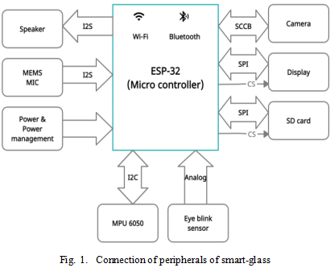

Fig.1. Block diagram of SmartGlass

**4.2. Data processing:**

***4.2.1. Data receiving from sensors:***

The data from sensors is collected by the microcontroller through GPIO peripheral in digital or analog format according to requirements and sensor output type. The I2C communication protocol is used to interface the MAX30100 pulse oximeter sensor and MPU6050 accelerometer sensor. After collecting the information/data from sensors this data is processed to produce output and according to these sensor outputs, MCU decides what operations should be performed.

To get image data from the camera, MCU uses an 8-bit parallel connection, clock signals and some other signals. After taking images successfully they are stored in a micro SD card. From here all the required sensor data and images which are present in the microcontroller memory will be stored in the cloud database through Wi-Fi connection using HTTP protocol and will also be displayed categorically on the display of smartwatch, smartglass and user’s mobile phone.

***4.2.2. Image processing and object/text/person detection:***

The image captured by the ESP32 camera board will be further processed by both the android app and cloud image processing. The advantages of using cloud image processing are accuracy and more relevant results and when the internet is not available, offline image processing at the mobile application will be better. So we divide this section into two sub-categories: online and offline image processing.

* **Online processing:** For online image processing and object detection, we can use different cloud-based AI platforms like 'Google Cloud Vision', 'Clarifai' etc. Just by using the API and authentication and simply uploading the image, image processing can be done in these cloud platforms. Google cloud vision is a paid platform for image processing, on a larger scale this platform will be affordable and it can be used to get more accurate and more relevant results**.** In this paper, we are using an open-source free cloud AI platform 'Clarifai' for the same purpose. In this cloud AI platform, we can make our trained model or can use the available trained models developed by other developers. User can choose which specific type of image he/she wants to detect (i.e. general objects, foods, text, etc.) by changing only the object id from the application. The microcontroller will click the photo in quarter video graphics array (QVGA) resolution (320x240 pixels) and will convert that into a base-64 encoded bit and will post an HTTP request to 'Clarifai' cloud. The response is in javascript object notation (JSON). The microcontroller separates the result from the JSON string and displays that on the LCD screen.
* **Tensorflow Object detection API:** TensorFlow object detection API is the framework required to create a deep learning Network that solves everyday object detection problems.

Now the two proposed model for object detection are SSD Mobilenet and scaled Yolov4. Both are discussed below:

***SSD MobileNet:***SSD stands for Single Shot MultiBox Detector. It is a very popular algorithm in object detection. The Tensorflow API was used to train SSD MobileNet on the COCO dataset. SSD MobileNet Architecture is a fully convolutional network that learns how to predict and categorize bounding locations in one go. It can be trained end-to-end.

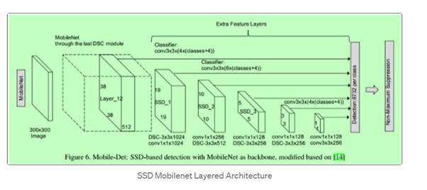

Fig. 2. SSD MobileNet flow diagram

By using this Algorithm we required only one single shot to detect multiple objects within the same image.

**Process of Implementation of SSD Mobilenet:**

Step 1. There are several Required python libraries such as: Tensorflow version 2 or higher, Pycocotools, Numpy, Os, Sys, Tarfile, Zipfile, Matplotlib.

Step 2. Compilation of protobufs.

Step 3. Loading the model.

Step 4. Loading our object detection SSD mobilenet v3 or v4 model for object detection.

Step 5. Get output on the test images.

As we all know SSD mobilenet is a good Machine learning algorithm but it has some drawbacks:

1. It is slow for a live camera feed object detection.
2. It requires high hardware requirements as compared to others.

Now to overcome these drawbacks YoloV4 can be used.

***Yolov4:*** Yolo Stands for You Only Look Once. As its name suggests it is talking about speed. Yolov4 is One of the fastest and most accurate object detection algorithms. It is also faster and more accurate than real-time neural networks.Yolov4 has 9 Convolution layers. In this procedure we are using scaled-YOLOv4 which is a notch above YoloV4. It has more classes in it than many other Yolo versions. It has approximately 90 classes for better object detection. This is a pretrained model also we can train this for more variety of classes

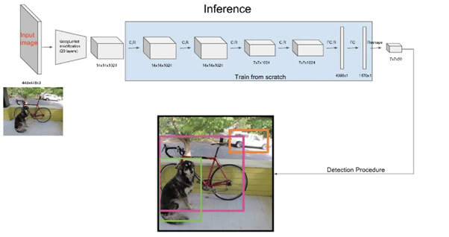

Fig.3. Block Diagram of Yolov4

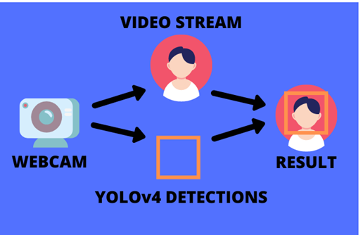

Fig. 4. Yolov4 Implementation using live camera feed

**Implementation of scaled YOLOv4:**

**Step 1.**Importing Dependencies like: Cv2, Numpy, PIL, Io, Html, Time, matplotlib etc.

**Step 2.** Cloning and setting up Darknet for YOLOv4

**Step 3.** Writing required functions to take input of camera and image files.

**Step 4.** Getting the scaled yolov4 weights file that is pre-trained to detect 90 classes (objects).

**Step 5.** Running tests on Test images ,Video feed ,Live video feed with accuracy.

* **Offline processing:**

1. *Person &. Object detect:*

Object detection is process of identifying or detecting objects instances using various methods which are related to computer technique related to computer vision and image processing.In this paper, we are using a python Machine learning algorithm known as TensorFlow. There are many pre-trained models available in TensorFlow. One of the most popular of them is the Frozen model which is based on the SSD MobileNetv3 algorithm.

Besides this Various other libraries of Python were also used such as Opencv2, os, matplotlib, etc. It can detect several kinds of objects, a person can also be detected in the Live feed of camera, image files, and video files.

One of the famous datasets used here is the COCO dataset having 80 classes in it. The main advantage of this approach is that it is very fast and very less processing is required. The result of the object which is present whether in video,image or live feed will contain a rectangular box around it with an object label on it.

1. *Traffic signs detection:*

Traffic signs are signs which are erected at the side of or above roads to provide instructions or provide information to road users. Signboard detection can be done using Python Machine Learning Algorithms known as TensorFlow, Keras. Other libraries of python will be also used here such as Scikit-learn, pandas, python imaging library (PIL), OS, OpenCv2. It's A Convolutional Neural Network technique that has the main advantage of giving high accuracy.

The dataset used here will have following characteristics such as it will be having 50000 images of different traffic signs which will then additionally be classified into 43 different classes.This is a huge dataset and quite varying.

The train folder in the dataset which will be used to train the model and the test folder in the dataset will be used for testing our model in the real word scenario.

It has 4 steps;-

1. Exploring the dataset: With the help of the OS library, iteration through all the classes present in the dataset and append images with suitable labels. PIL library will be used to open image content into a numpy array. Then conversion to a NumPy array to fed it to our model.
2. Building a CNN model: It is a Convolutional Neural Network (CNN) model which is best suited for image classification purpose
3. Train and validate the model: After successfully building the required model we train the model andtry to improve accuracy.
4. Testing our model with test dataset: Now different images will be fed to the model. Giving the final output having an accuracy of about ~95%. Live feed of the traffic signs can also be fed using the OpenCv2 python module.

***4.2.3 Wit Ai Implementation:***

The Basic Flowchart of Voice Recognition is shown below.

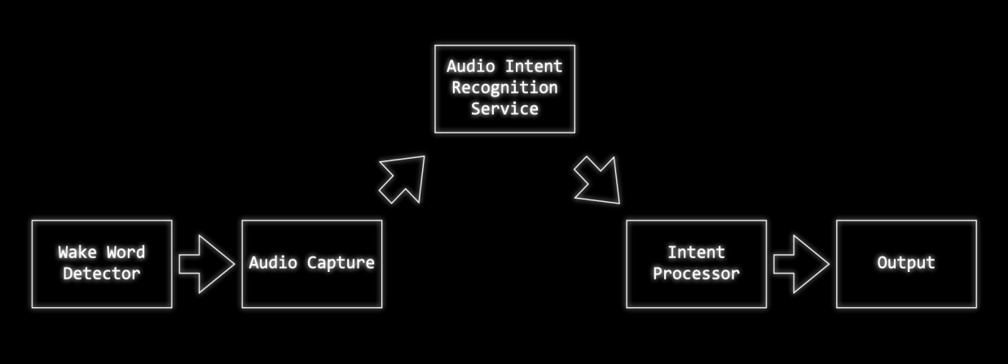

Fig. 5. Flowchart of Wit Ai implementation

For User voice Recognition following are the steps used:-

1. In the created application ,it is needed to train it to recognize what our users will say. There are three main building blocks of a Wit.ai application:

* Intents
* Entities
* Traits

Our application samples phrases and trains it to recognize what intent it should map the phase onto.

1. Phrases are fed into Wit.ai - for the first phrase we enter we'll create a new intent "Turn_on_device".

As there is a need of adding more phrases we'll assign them to this new intent. As more examples is fed wit ai model will learn what kind of phrases should map onto the same intent.Whenever,In the future when model sees a new phrase it has never seen before - e.g. "Turn on the living room" it will be able to recognise that this phrase should belong to the Turn_on_device intent.

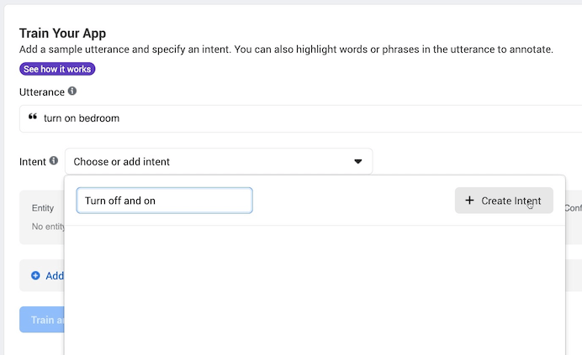

Fig. 6. Training of Application in wit ai, choice of intent

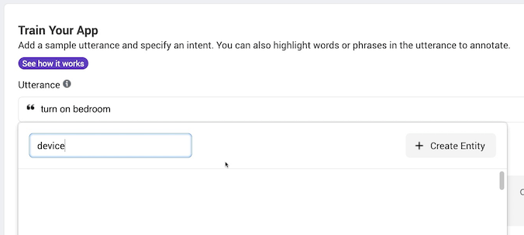

Fig. 7. Training of Application in wit ai, choice of utterance

1. In the end from the model it is needed that it is able to detect what the user is trying to do to the device. For this we use Traits. Wit.ai has a built-in trait for detecting ‘on’ and ‘off’ so we can use this for training.

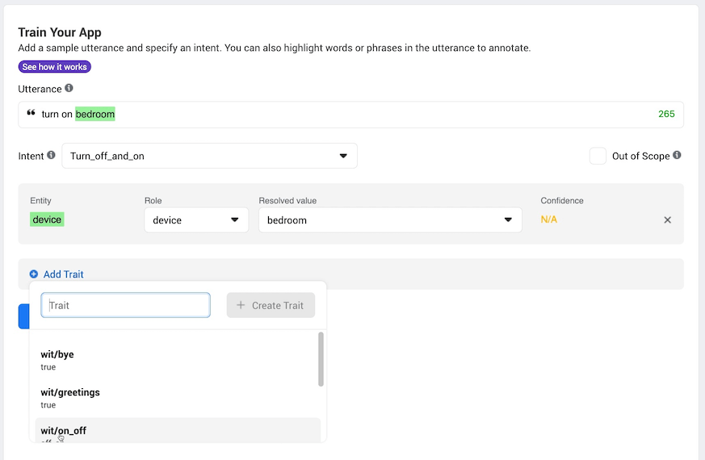

Fig. 8. Training of Application in wit ai, Addition of Trait

1. Once the model is trained for few sample phrases as mentioned above it will start to automatically recognize Intent, Entity and Trait.

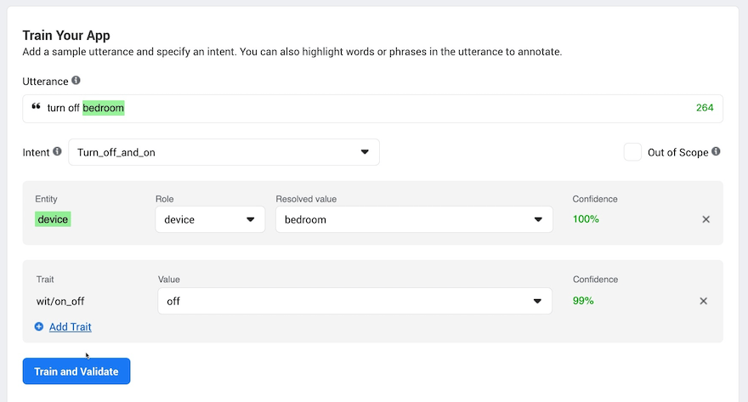

Fig. 9. Training of Application in wit ai, Validating the application

1. If the model fails to recognise any of these then you can tell it what it should have done and it will correct itself.
2. Once this training of model is done user can provide sample audio or can speak in the microphone and it will predict what user is saying or trying to say with the provided confidence between (0-100%)

***4.2.3. Sound conversion from speech to text:***

One of the most important functions of the “Smart Glasses” is speech-to-text conversion. For the following task Python and its Various libraries will be used. One of them, a very famous python library known as gTTS(Google Text-to-Speech) library will be used. It is a python library that interfaces with Google Translate API. Other libraries such as Speech Recognition, OS will be used. In this, the Input will be given through the mic and the output will be displayed on the screen. This feature is very helpful for the person who is blind or having problems with vision. Here all the names of the classes of the dataset are stored on the SD card of the smart-glass. When any object is detected, the MCU plays the ‘.wav’ file of that particular object from the SD card to the speaker.

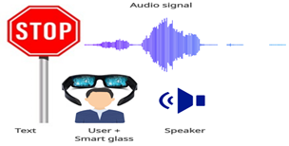

Fig. 10. Text to speech converting

***4.2.4. Mobile application***

For the complete access of the SmartGlass , an android application is being used which will be equipped with features like tracking the beneficial data like object detection and other related results, calls and messages notifications, and complete customization of the smartglass and the smartband. The smartband data will be in sync with the smartglass and the application. The application will also be capable of executing the python code blocks with the help of the “cgitb” library provided in python.The technologies used in the application are java, and python and the IDE (Integrated Development Environment) being used is Android Studio. The data captured by the smartband and the smartglass will be stored on cloud servers which can be accessed only by the users. The application will be serving as the main user control interface.

The customization options provided by the application will be setting up the accounts for various services i.e the search functionalities, map functionalities, and various other optional features like voice notifications, etc.

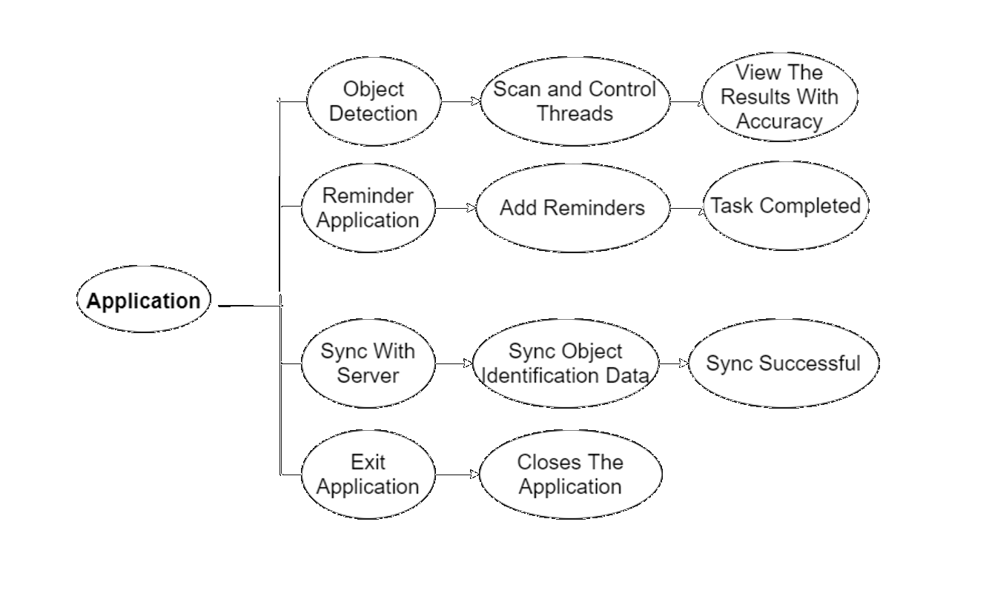

Fig. 11. Block diagram of the android application

**Android Studio:** Android Studio is the Integrated Development Environment (IDE) used by the developers of Google's linux based operating system Android for the creation of android applications for various devices Like android smartphones, smartwatches, tablets, televisions, vehicles, etc. Android studio is based on the JetBrains' Intellij Idea software which is a very popular IDE for java development. It was first announced by Google in may, 2016 in its Google I/O Event. Since android is an open source operating system and users are permitted to publish their applications on the google play store, Android studio is free of cost and is available for all Windows, Linux and MacOs users. The supported languages for android development for android applications are java and kotlin. Android Studio was an early access preview platform originating from v0.1 in May 2013, subsequently giving a start to its beta version beginning from v0.8. The first successful and bug-free version i.e. v1.0 came out in December 2014. When an application is designed and developed by the means of Android Studio, it can be published on the google play store.

The features of android studio are support of Gradle based build, quick repairs with android specifications, compatibility with different versions, security features, activities based on templates for design of different features, drag and drop component support, allows to show the application on various screens at the same time and has a Android Virtual Device (AVD) i.e A virtual smartphone of a specified android version that is used to run and view the application that are in the development phase. It is equipped with a smart code editor, and an in-built cloud and firebase support.

**Gradle:** Gradle is an automated tool for building for software development across various languages. It manages the development stages while compilation and from packaging to testing, deployment, and publishing. The languages supported by gradle are java, kotlin, scala, groovy, C/C++, javascript. The most important job of gradle is collection of statistical data having information about libraries used for software development all over the world. Gradle builds on the theories of Apache Ant, Apache Maven,and brings a groovy and Kotlin based domain-specific language corresponding with the XML-based project configurations required by Maven. Gradle uses a directed acyclic graph to find the position in which tasks have to run,by providing dependency management . Gradle runs on the java virtual machine (JVM).

Gradle was built for multiple project development at the same time, which can be heavy. Gradle functions on a collection of actions that run serially parallelly. Additional builds are supported by finding out the components of the build tree that are always updated. Any activities that are dependent only on those parts are not required to be executed again. It also provides the functionality of caching of build components over a local network using the Gradle Build Cache. It generates web based build visualizations called Gradle Build Scans. It is open for new functions and other programming languages with a plugin functionality. It is given simultaneously as an open-source software under the Apache License 2.0, and was released initially in 2008.

**TensorFlow:** TensorFlow is an unpaid and public software library for machine learning and A.I. It can be considered for various tasks but has a primary focus on learning and development of deep neural networks. TensorFlow was designed by the Google Brain team for Google's work in research and development. The first version was released under the Apache License 2.0 in 2015. In 2019, the new version of TensorFlow was released by Google as TensorFlow 2.0. TensorFlow is considered for a large diversity of programming languages, like python, javascript, C++, and java. This feature allows it to be used in a large range of applications in various sectors. TensorFlow is considered as Google Brain's second-generation system. v1.0.0 was released in February, 2017. As the design runs on one device, tensorflow can be used on many CPUs and GPUs. It is present on 64-bit linux, macOS, windows, and smartphone platforms like Android and iOS.

Its design permits for the easy development and deployment of computation over many platforms (CPUs, GPUs, TPUs), also from desktops to bundles of servers to mobile devices. TensorFlow computed results are displayed as informative dataflow graphs. TensorFlow is derived from the functions that the neural networks perform on multidimensional data arrays, which are called tensors. Jeff Dean in a Google I/O conference highlighted that under the TensorFlow mentioned repositories, Google contributed only 5 of them and total repositories were 1A short range wireless communication technology allowing devices in a close range to interact and share files and information among them.

**Bluetooth:** It is a short range wireless communication technology allowing devices in a close range to interact and share files and information among them.It operates using ultra high frequency waves on a frequency between 2 GHz and 2.48GHz. It was introduced in the year 2000 and currently, the latest version being Bluetooth 5.2. It uses less energy and costs less to build as compared to WiFi. Its less energy use also makes it very difficult to suffer from other difficulties for proper connections and blockages with other components or devices in the same frequency range. With major improvements over the years, all devices equipped with bluetooth 4.0 and above are optimized for saving the battery and increasing its life. Since bluetooth operates on a low range technology ,it makes it a very secure medium for communication among various devices. The devices also change their operating frequency many times in a second. All the connections of bluetooth are encrypted meaning other devices cannot view or access the data being transmitted from one device to another. In modern versions, users and service providers can also limit the activities that can be performed using bluetooth.

**Process:** Since Android Studio is an open source, easy to use and user friendly integrated development environment, the process of the creation of the app is not very complex. The prerequisites for the creation of the application is basic knowledge of android studio, gradle, ui/ux and java.

The steps are as follows**:**

i) Open Android Studio and configure the project with respect to the jdk and gradle version.

ii) Open The activity_main.xml file and design the layout of the home screen.

iii) Create new activities by right clicking on the project and selecting new activity.

iv) Design the layouts of the new activities.

v) Program the backend working of the android pages in Main.java file in the java folder in src in java or kotlin using various libraries.

vi) Design the Android Virtual Device and run the app for debugging.

vii) When the design and implementation is complete, build the apk and install it on other devices for further use.

**4.3. Data storage:**

All the sensor data will be stored both in the local database and in the cloud database. All the data of a particular user will be stored in a particular cloud database table allocated to him/her and can access the data using appropriate authentication. The database will be used as a real-time database so that the user can access the current values of data through the application easily. In the cloud, the image will be stored in the base-64 format so that we can easily upload and access the image data/content. Users can store the data in the micro secure digital (SD) card according to his/her need as a local database. The images will be stored on the sd card in ".jpg" format and the time-lapse video will be stored in ".avi" format.

**4.4. Data transmission:**

The data transmission is mainly done in two ways, one is data transmission between the MCU and the cloud database and the other one is the data transmission between the MCU and the mobile phone of the user.

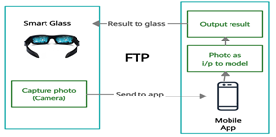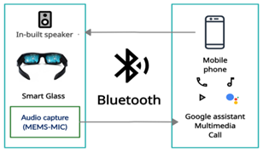All the sensor-based data is stored on the cloud database through connection-oriented transmission control protocol (TCP) protocol using in-built wifi (IEEE 802.11) of the MCU. The mobile application takes a maximum of the data from the cloud, and the image and video files are transferred between the MCU to the application directly through the file transfer protocol (FTP). For the file transfer using the FTP server, the user has to be in the same local area network in which the device is connected.

Fig.12. File transfer between smart-glass Fig.13. Audio transfer between smart-glass and mobile using FTP and mobile using Bluetooth

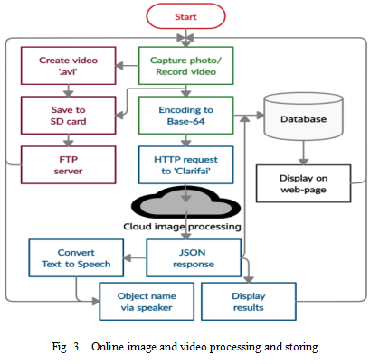

Fig. 14. Online image and video processing and storing

**4.5. Special functions:**

***4.5.1. Google Search:***

In our daily life we must have experienced an urge to google search. So, it is important that it should be a basic feature of smart glasses. So,to implement this functionality we use some basic Web scraping method which can be implemented using Python. To achieve this is using “requests” , “beautifulsoup” and “google” python libraries.Using python library google we can get results of google search from python script. We can get a link of the first few search results and select appropriate links according to our use.The input to Google may be given using some voice commands and the output can be displayed on screen.

***4.5.2. Gesture control:***

For seamless interfacing of the smartglass the gestures like nodding head up and down will be an additional feature for the user to operate the smartglass. These functionalities will be implemented by the MPU6050 accelerometer sensor which is very accurate and capable of providing instantaneous data to determine gestures.

***4.5.3. Entertainment:***

*View Images:* The user can upload some images to the sd card of the smart glass from the mobile application using FTP protocol. The images are converted into 24-bit ".bmp" format. When the user wants to see those images on the smart-glass display, the microcontroller retrieves the images from the SD card, converts them to hex files, and displays them on the TFT LCD screen.

*View Videos:*When the user wants to view some entertainment videos on the screen of the smart glass in his/her leisure time, he/she has only to provide the video link/uniform resource locator (URL) on the app screen. The application will download the video from the source URL in ".mp4" format and will separate the image and audio. The image will be in animated ".gif" and the audio will be in ".pcm" format. Those audio and animated gif files will be transferred to the SD card of the smart glass using FTP protocol. The microcontroller decodes the gif file and displays it on the TFT display and plays sound using inter-integrated circuit sound (I2S) protocol.

*Playing Games:* The user can also play some interesting games with the CPU in their leisure time if it feels boring. For controlling the game, two touch pins will be used.

**4.6. Power and power management:**

For being a low-powered device, ESP-32 CAM uses a very low power around 900mWatt (when flash-light is off). But at night time, due to flash-light, it consumes a little bit more power of around 1550mWatt. When the module is in an idle state (nothing to transmit or receive), it also consumes the same power as the time of transmitting or receiving. To reduce unnecessary power consumption in an idle state, the device uses various sleep modes. When the MCU has nothing to do it automatically goes to the deep-sleep mode where the power consumption reduces to 50 µWatt. In this sleep mode only the real-time clock (RTC) controller, RTC peripherals, and RTC memories are powered on. If any type of interrupt (notification, button pressing, etc.) is received, the ESP comes back to normal mode.

Table 1: Comparison between all states of ESP32 CAM

|  |  |  |  |  |
| --- | --- | --- | --- | --- |
| **Item** | **Normal** | **Modem-sleep** | **Light-sleep** | **Deep-sleep** |
| Wi-Fi | ON | OFF | OFF | OFF |
| System clock | ON | ON | OFF | OFF |
| RTC | ON | ON | ON | ON |
| CPU | ON | ON | PENDING | OFF |
| Current | 180 mA @ 5v | 20 mA @ 5v | 0.8 mA @ 5v | 10 µA @ 5v |

**CHAPTER 5**

**RESULTS AND DISCUSSION**

**____________________________________________________**

**5.1. Object detect using esp32 cam:**

The esp32 CAM sends the captured image to Clarifai cloud and receives an http response which contains the objects present in the captured image.

The following shows the received JSON string when the response code is 200 (OK).

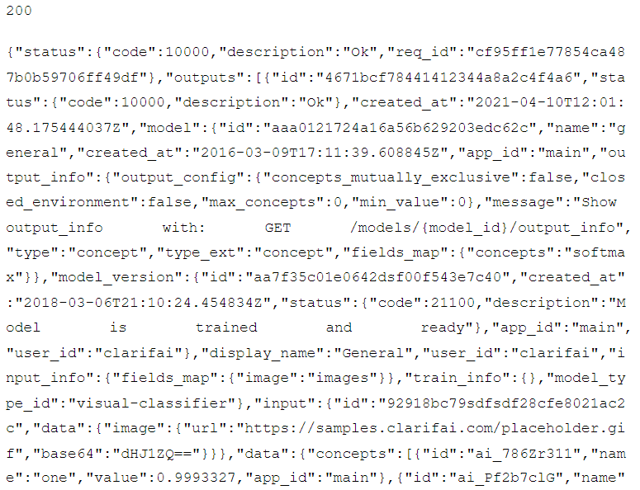

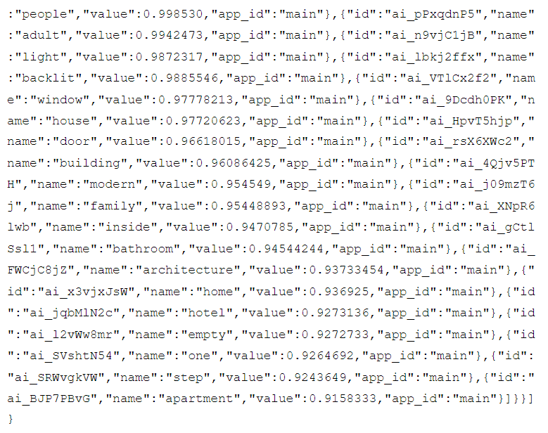

Here are the top 5 detected object names and their probability value-

=====================

Name:one

Prob:1.00

=====================

Name:people

Prob:1.00

=====================

Name:adult

Prob:0.99

=====================

Name:light

Prob:0.99

=====================

Name:backlit

Prob:0.99

=====================

one, 1.00

people, 1.00

adult, 0.99

light, 0.99

backlit, 0.99

The captured image, received object names and their probability values are updated to the web-page.

Object1=one&Value1=1.00&Object2=people&Value2=1.00&Object3=adult&Value3=0.99&Object4=light&Value4=0.99&Object5=backlit&Value5=0.99&Data=%2F9j%2F4AAQSkZA…...xkQDyWyrlH6ikqjQ%2F%2FZ

**5.2. FTP connection with the application:**

Using any FTP client application on the user’s android, he/she can view all the images/videos captured/recorded previously using the camera of the glass. Figure 16 shows all the files present in the SD card of the smart glass. Figure 17 shows an image file after downloading using the FTP protocol.

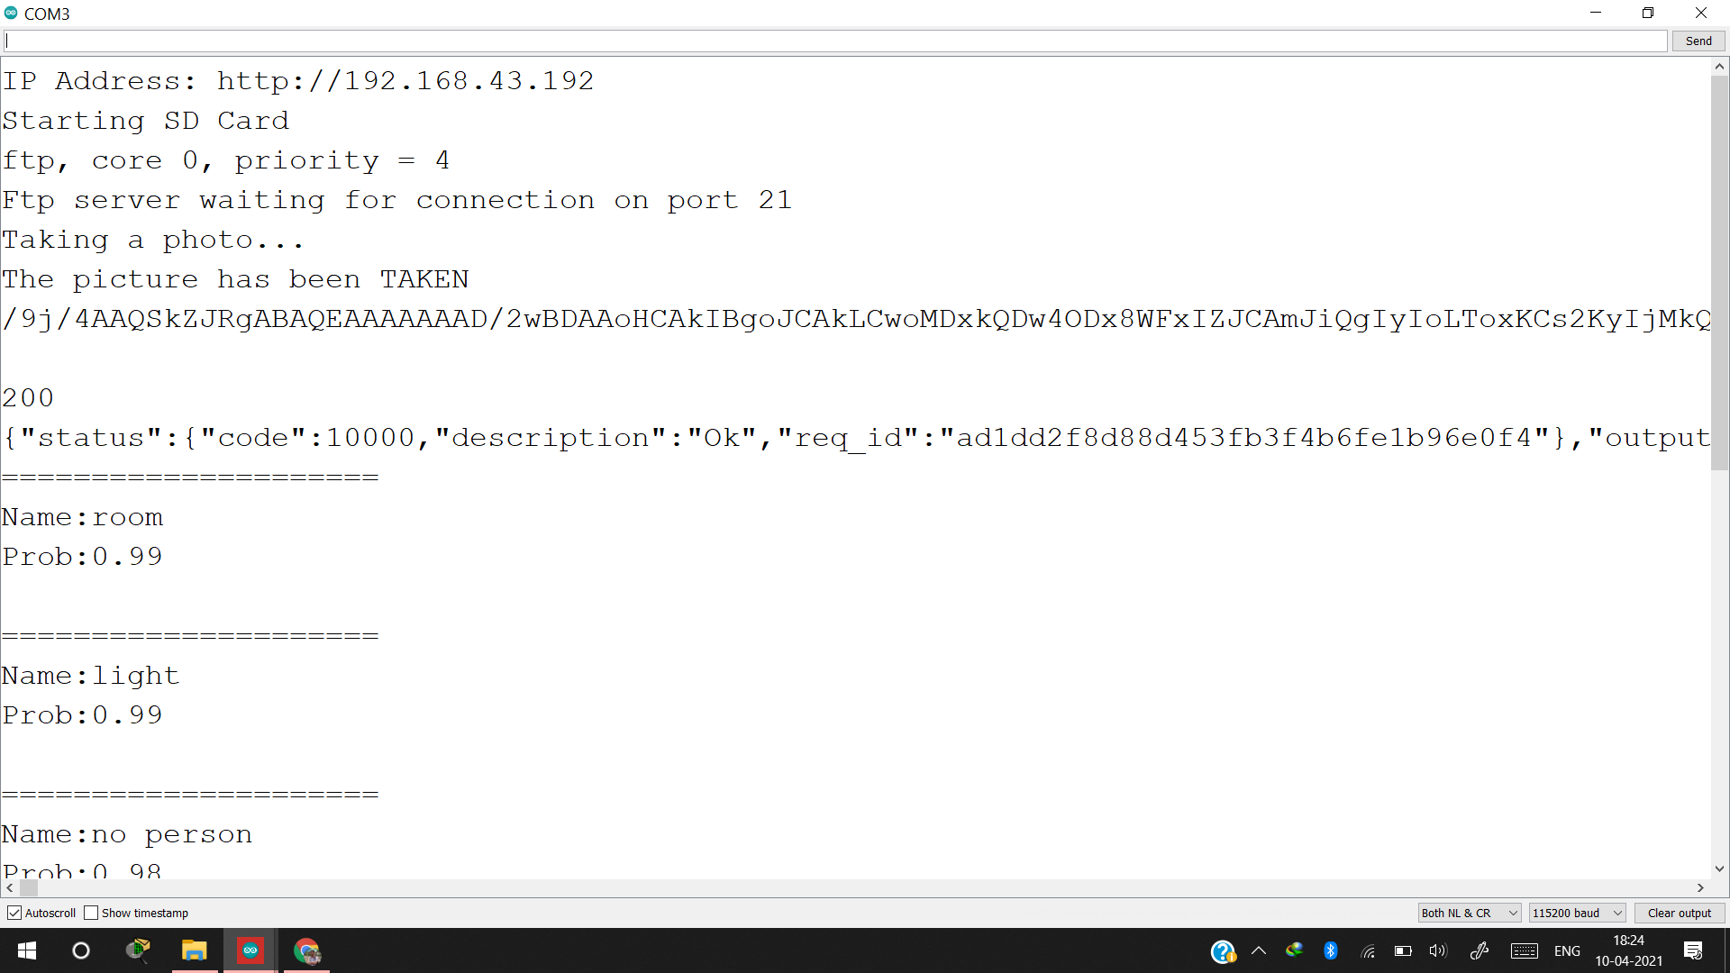

Fig. 15. Output at Serial monitor

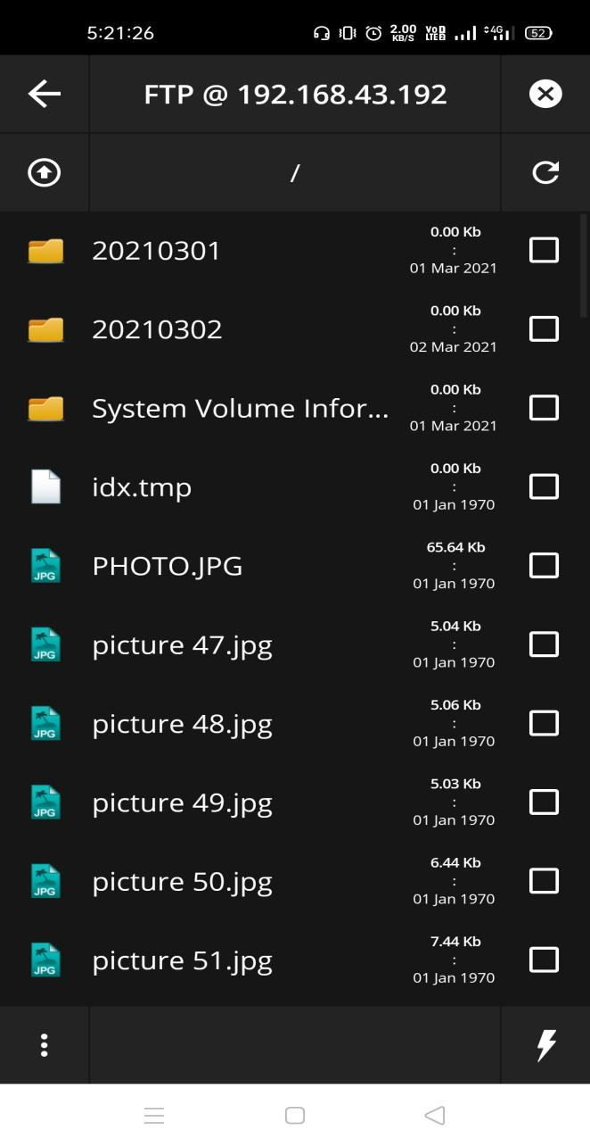 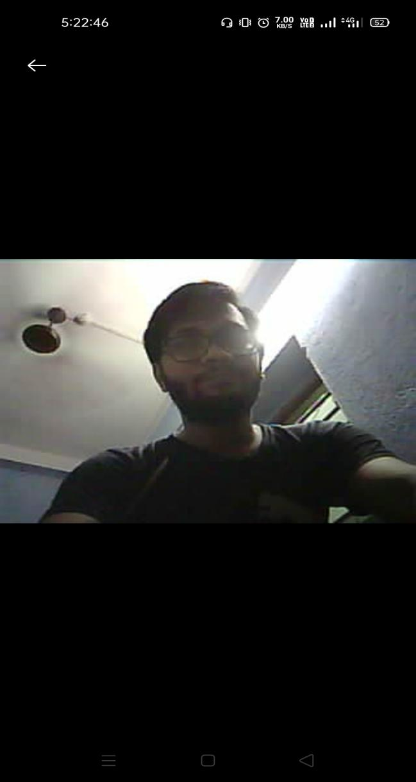

Fig. 16. Mobile file manager app showing data Fig. 17. Browsing Image taken by ESP32

from ESP32 SD card over FTP on android image viewer

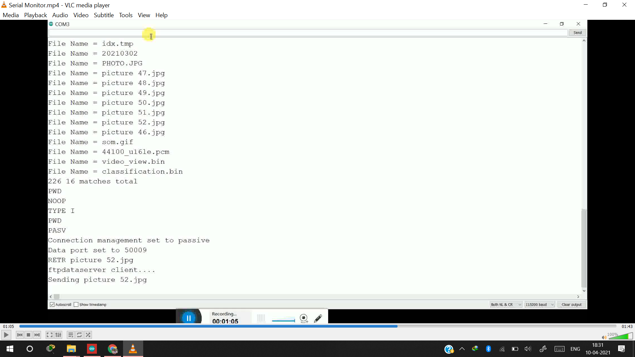

Fig. 18. Arduino IDE serial monitor, showing content files and their sharing over FTP protocol

**5.3. Displaying results on web-page:**

The user can view the image, detected object names, and their corresponding probability values on the webpage. Figure no 19, 20, 21 shows the output on the webpage.

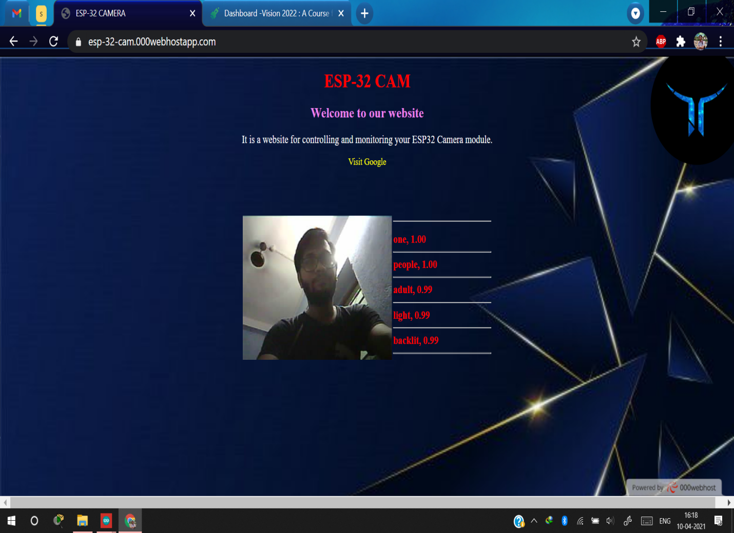

Fig. 19. Webpage displaying the predicted object/person results

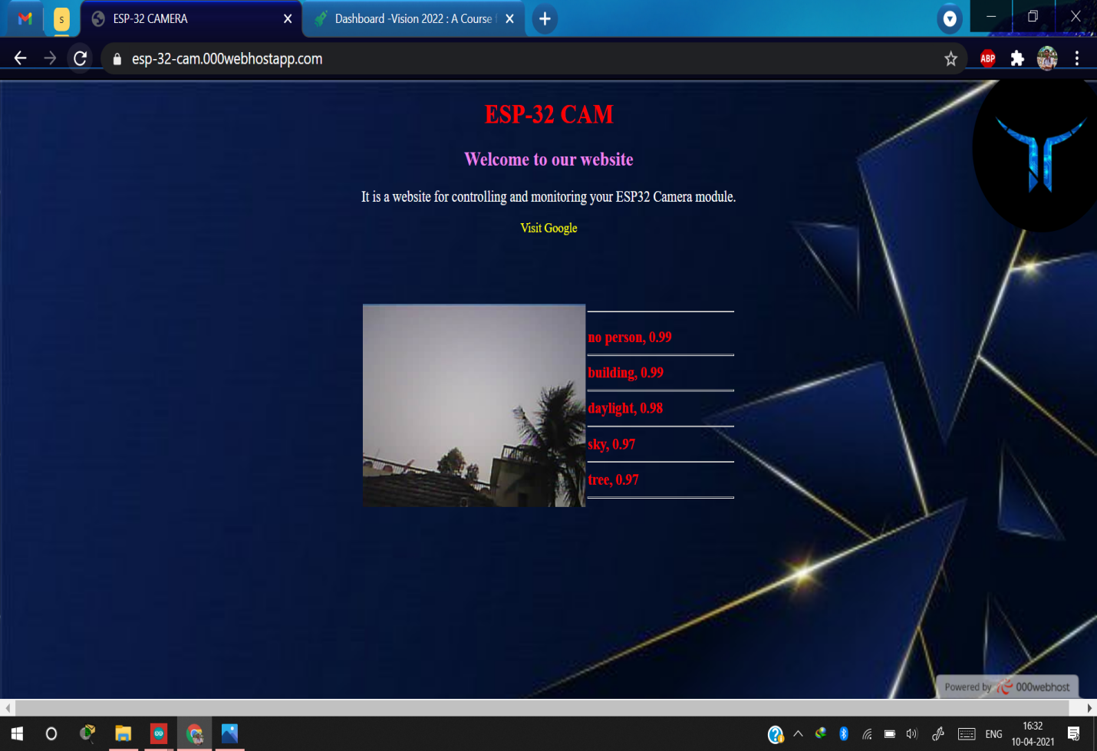

Fig. 20. Webpage displaying the predicted results of random image taken

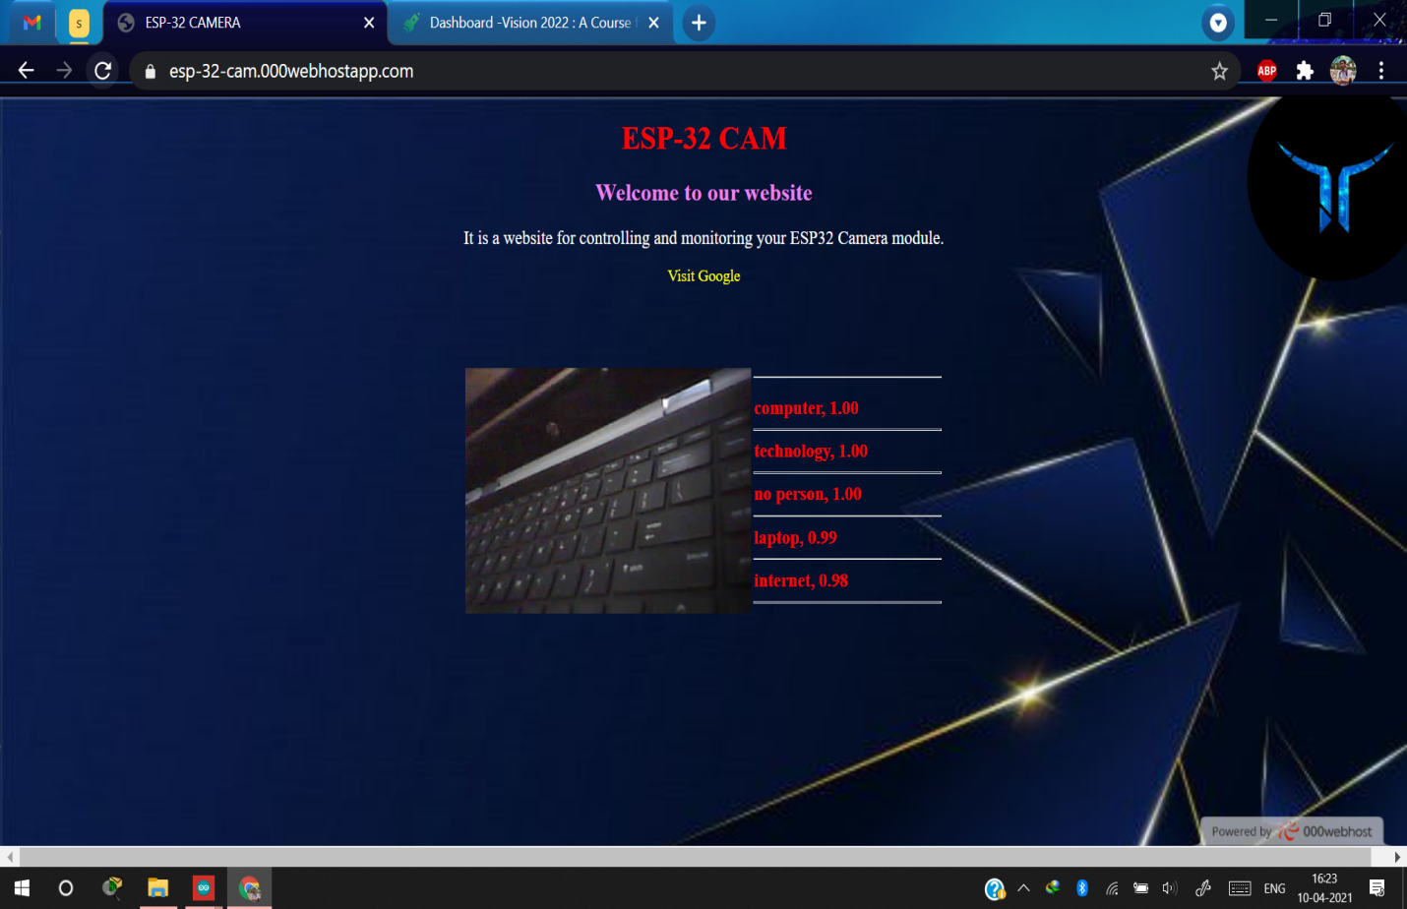

Fig. 21. Webpage displaying the predicted results from image of a part of laptop

**5.4. Speech to text output:**

Here, one can see we have given input through the microphone and got the output on the console which will further be displayed on the screen of smart glass.

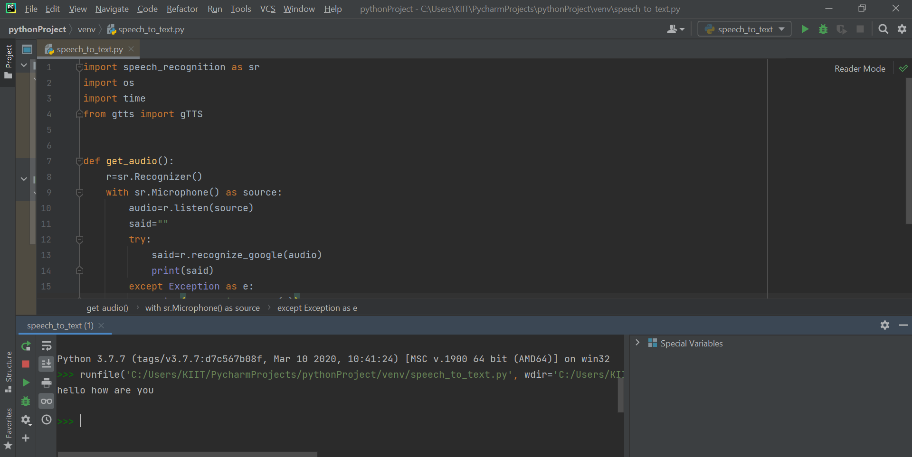

Fig. 22. Speech to text ML model output

**5.5 Person & Object Detection:**

Here,There are Four types of Input which can be given to this Machine Learning Model namely-File (in jpeg ,png etc format),Video Feed and Live Camera Feed and Live camera Photograph. Examples Results for all scenarios are attached here:-

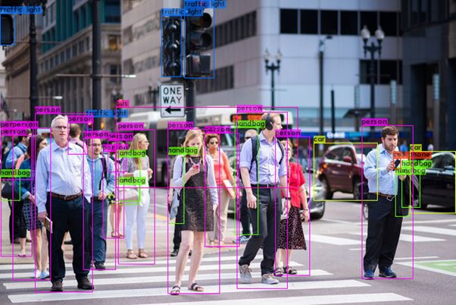

Fig. 23. Image as Input using SSD mobilenetv4 and scaled-yolov4

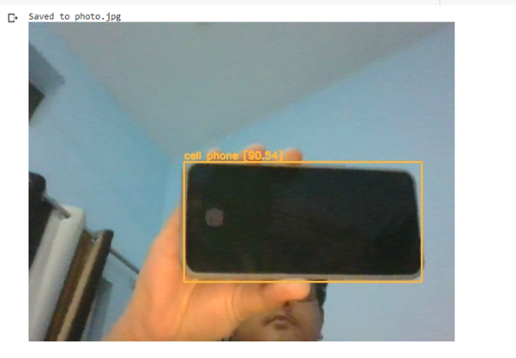

Fig. 24. Object detection using Capturing using camera

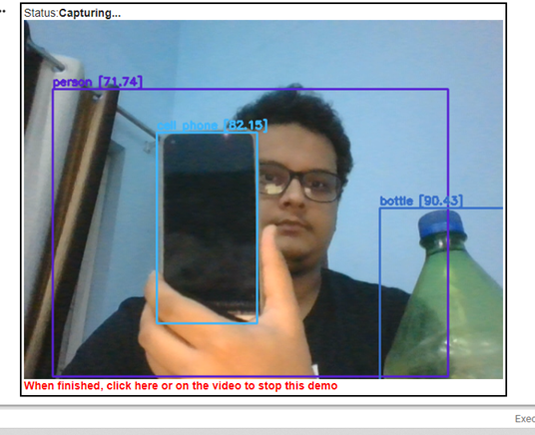

Fig. 25. Object detection using live camera feed

**5.6. Temperature and steps output:**

The temperature and Steps are measured by MPU6050 as discussed in this paper. The accelerometer sensor will be mounted on the smartwatch in close contact with the body to properly get the body temperature. The Steps are measured by calculating the change in acceleration of hand while walking and running. The below figure shows the output of the MPU sensor with the data measured having acceptable accuracy.

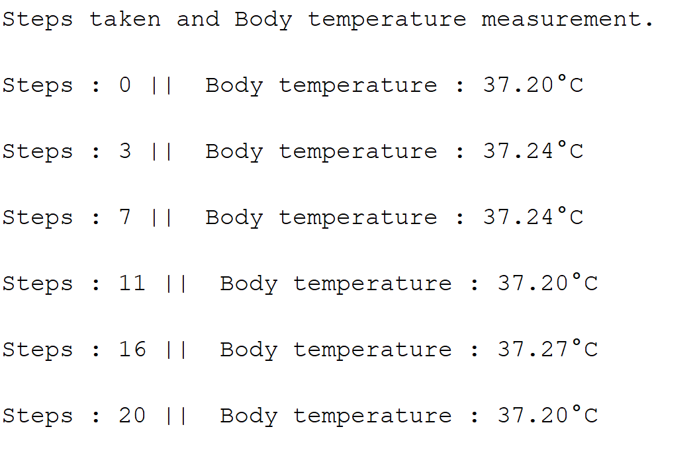

Fig. 26: Calculated steps taken and body temperature output from MPU6050 sensor

**5.7. Android Application UI**

The application consists of a homepage which consists of four buttons where each button is a link to other features of the application. The application consists of features like object detection, bluetooth connectivity, maps functionality, reminders, etc.

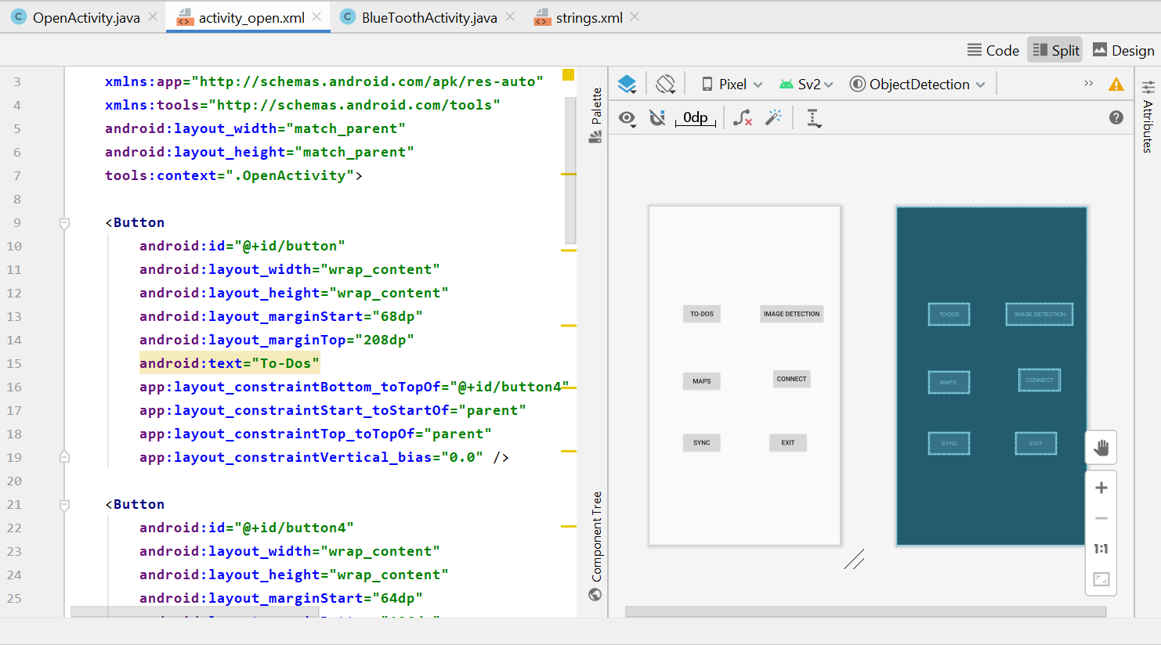

Fig. 27. Layout and Code Snippet of the Main Interface

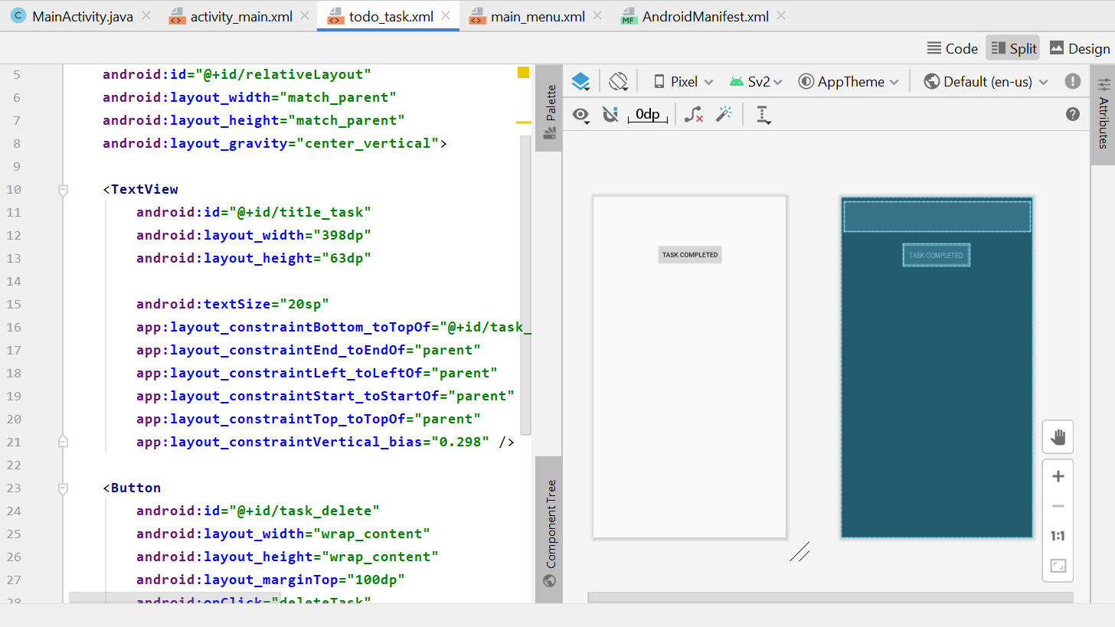

Fig. 28. Layout and Code snippet of the ToDo List Interface

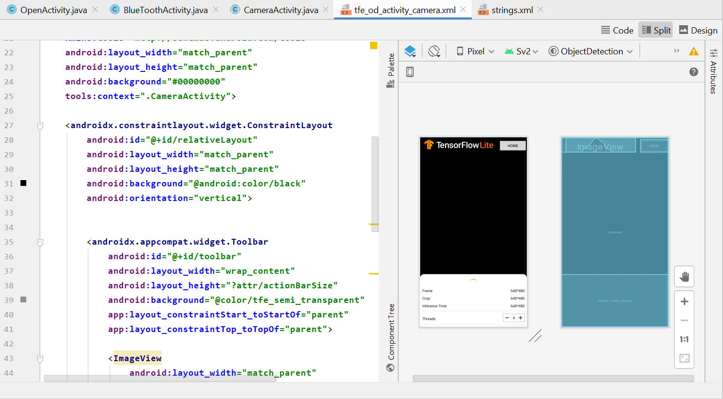

Fig. 29. Layout and Code Snippet of the Object Info and Thread Control Interface

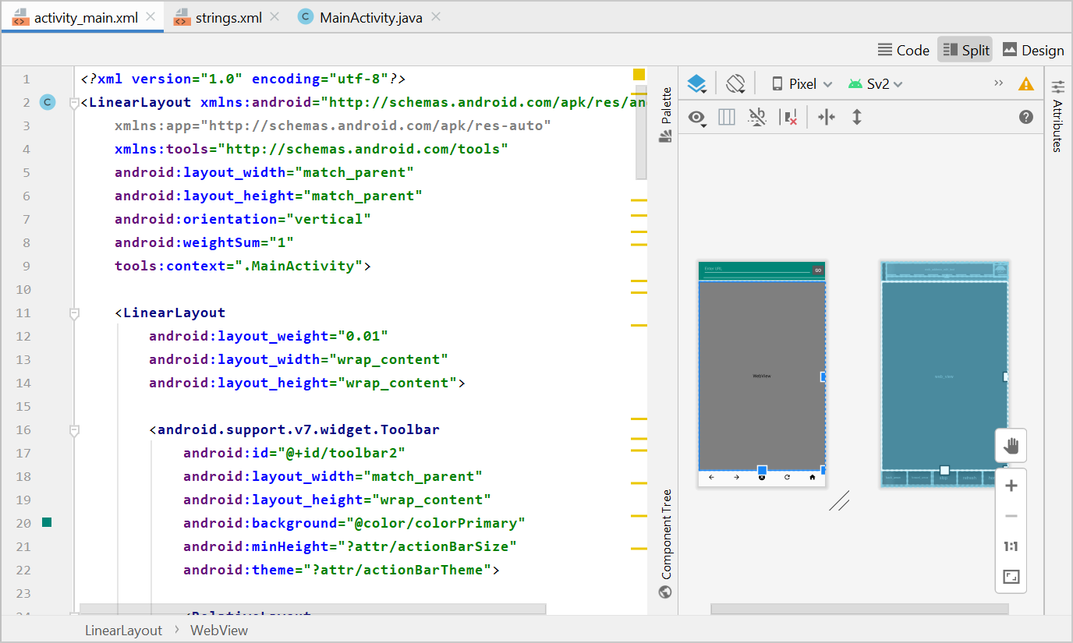

Fig. 30. Layout and Code Snippet of Browser Interface

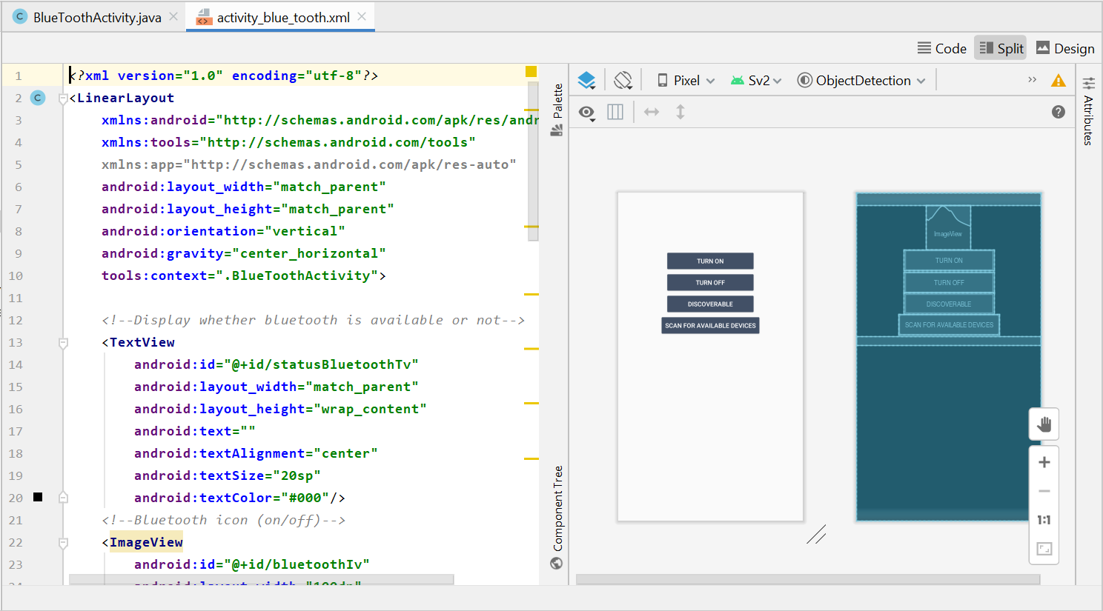

Fig. 31. Layout and Code Snippet of the Bluetooth Connectivity Interface

**5.8 Android Application Results**

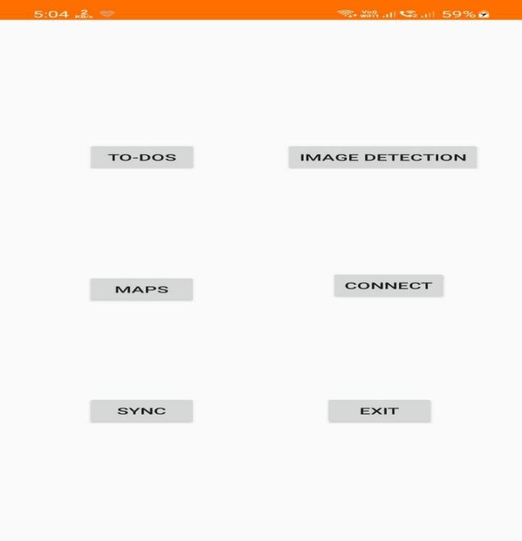

Fig. 32. Layout of The Home Screen

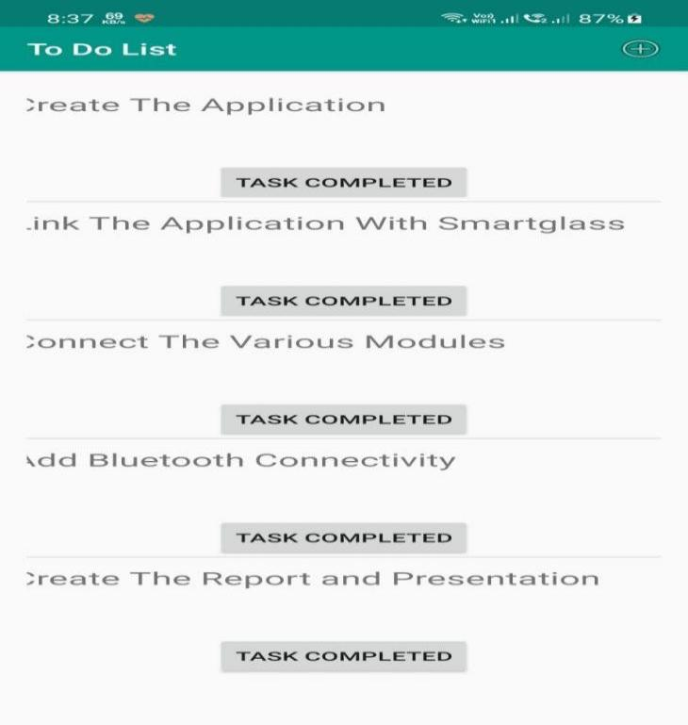

Fig. 33. Layout of the Todo List



Fig. 34. Layout of the Todo List (No Activity)

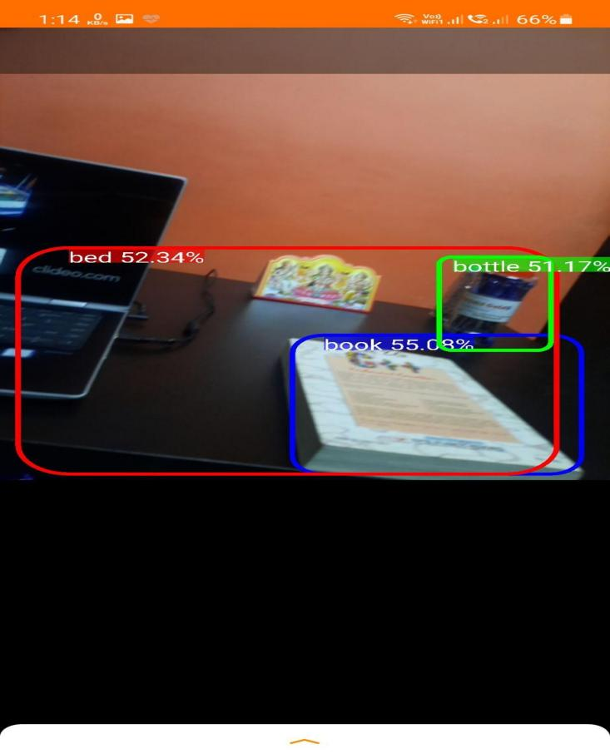

Fig. 35. Layout of the Object Detection Interface

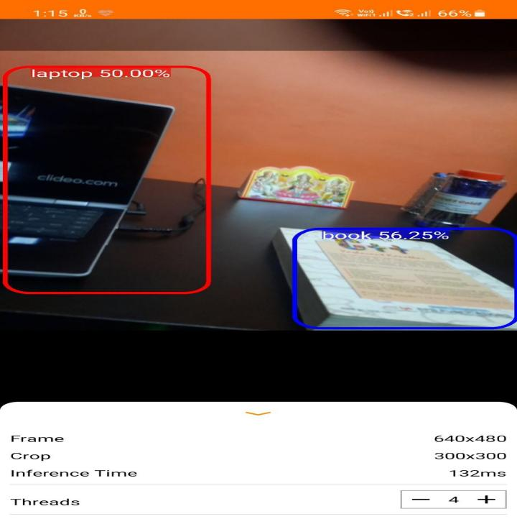

Fig. 36. Layout of the Object Detection Interface With Thread Control (4 Threads)

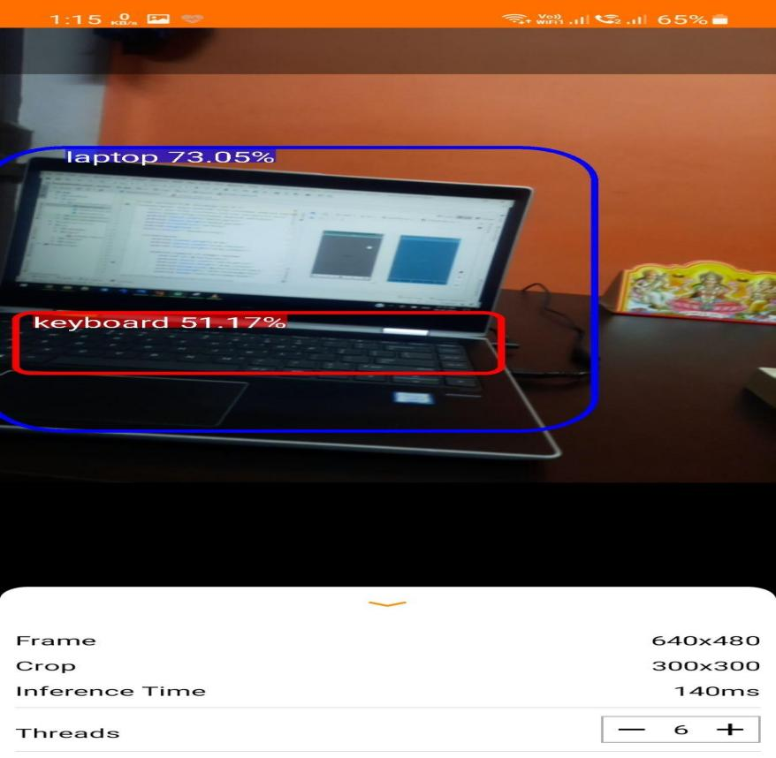

Fig. 37. Layout of the Object Detection Interface With Thread Control (6 Threads)

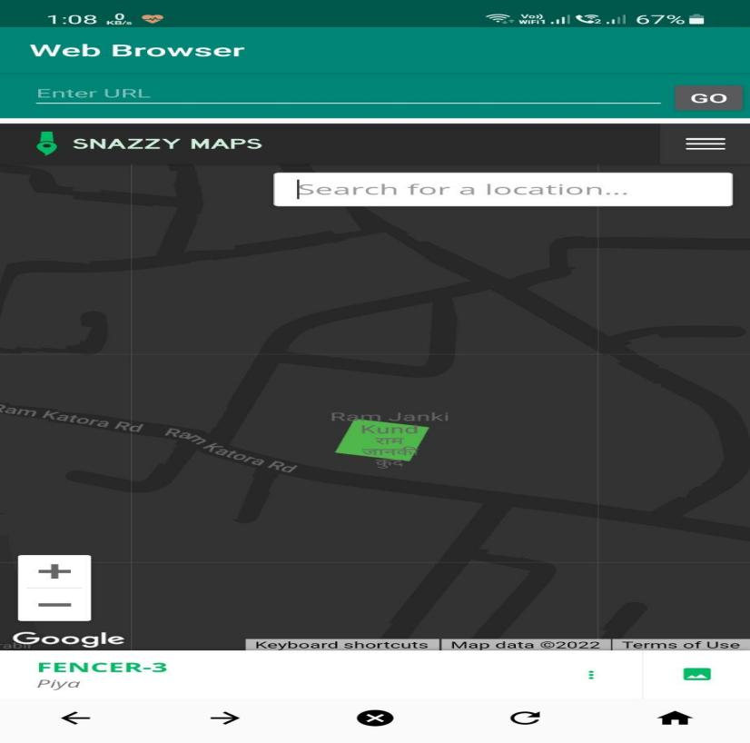

Fig. 38. Layout of the Browser Interface (with Maps)

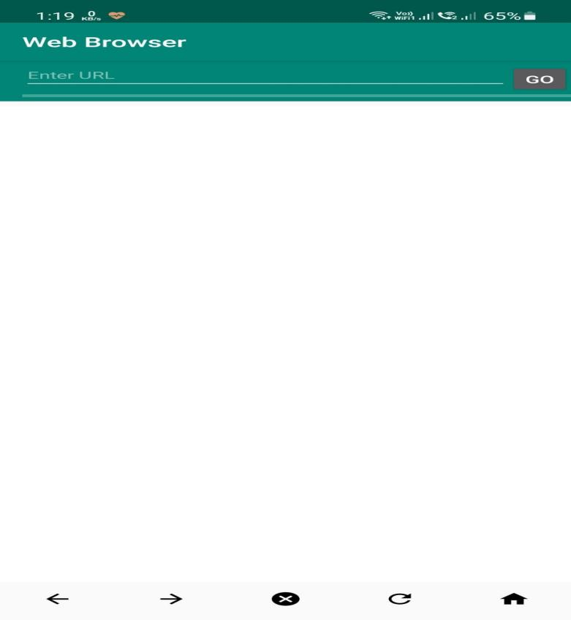

Fig. 39. Layout of the Browser Interface (Empty)

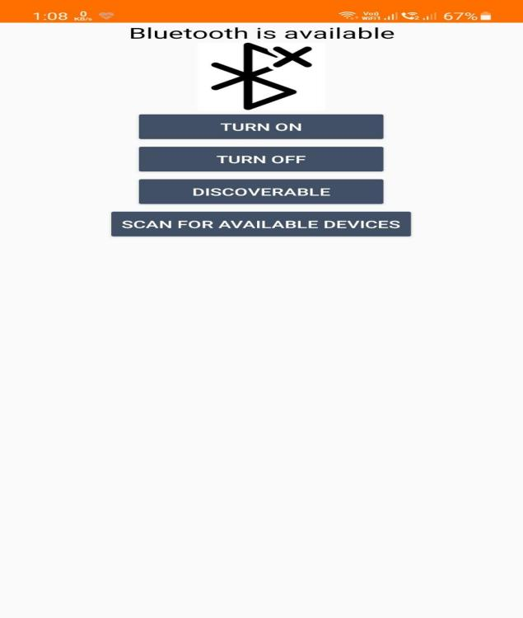

Fig. 40. Layout of the Bluetooth Connection Interface (Bluetooth Off)

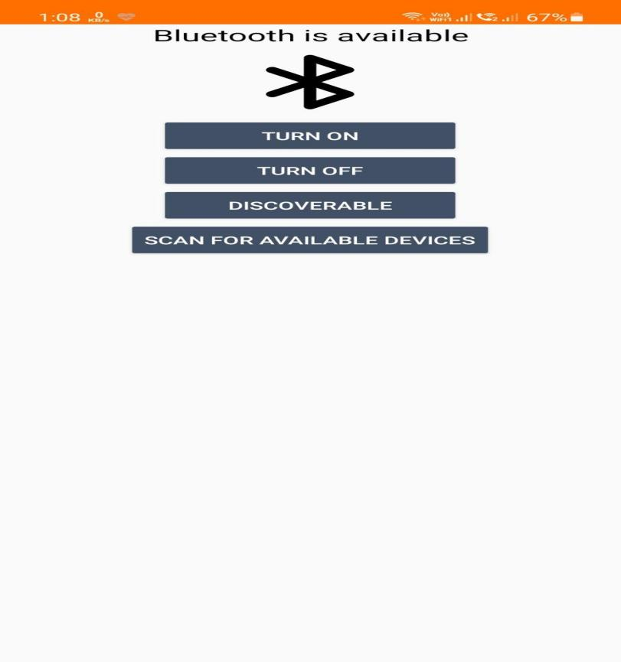

Fig. 41. Layout of the Bluetooth Connection Interface (Bluetooth On)

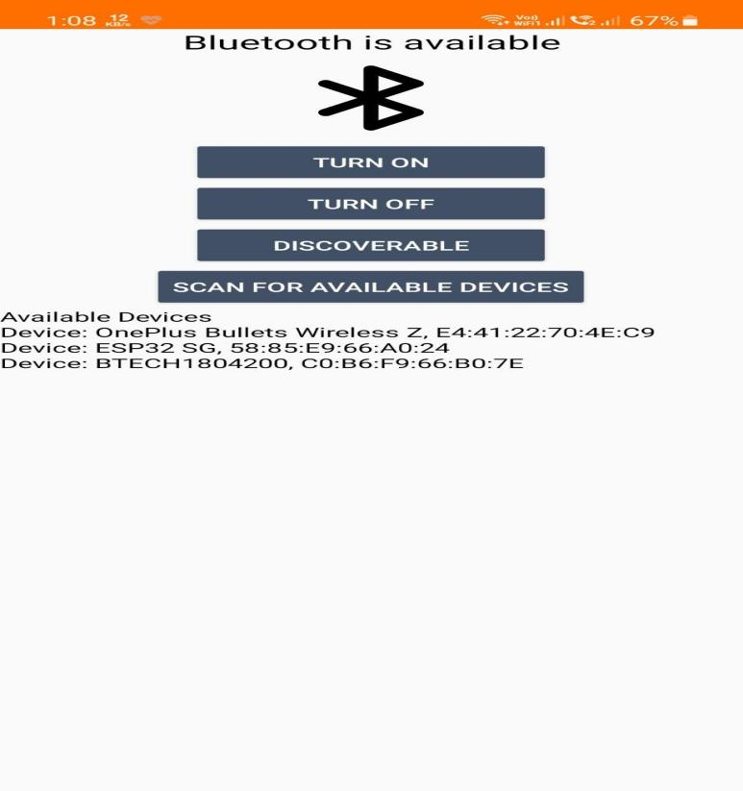

Fig. 42. Layout of the Bluetooth Connection Interface ( Devices List)

**CHAPTER 6**

**SOCIO-ECONOMIC ISSUES**

**6.1. Cost Analysis:**

Costs of various components that are used in proposed solution are:

**Table 6.2. Cost analysis table**

|  |  |  |  |
| --- | --- | --- | --- |
| **Component** | **Price(INR)** | **Quantity** | **Total (INR)** |
| **ESP32 CAM** | **750** | **1** | **750** |
| **OLED(128x64)** | **250** | **1** | **250** |
| **MAX30100** | **200** | **1** | **200** |
| **MPU6050** | **100** | **1** | **100** |
| **Li-po Battery** | **150** | **1** | **150** |
| **Eyeblink Sensor** | **150** | **1** | **150** |
| **IR Sensor** | **50** | **4** | **200** |
| **Frame** | **1200** | **1** | **1200** |
| **Other Passive components** | **150** | **1** | **150** |
| **Lens and glass material** | **200** | **1** | **150** |
| **PCB printing** | **100** | **1** | **100** |
| **Miscellaneous** | **500** | **-** | **500** |
|  |  | **Total** | **3900** |

The cost of some components may vary depending on availability.

**6.2.** **Safety analysis**

**Latency issue:** There may be some latency in image or video processing as they are being processed on user’s mobile phone and on cloud so there are chances that user sometimes may face the latency due to slow internet connection.

**Privacy:** User’s privacy can be assured with some security measures but the privacy of others may be compromised because the smart glass camera will be working most of the time due to this some persons may infringe in other’s privacy and may take their photo or video without their consent.

**6.3 Global impact**

The smart glass is an intelligent gadget capable of doing some tasks that a smartphone does but on a smaller scale. The smart-glass provides ease of use resulting in increased work efficiency.

The Applications of smart glass are:

**Environmental Analysis-** Smart-Glasses can have a plethora of integrated features for making tasks easy. Their biggest strength is an independent Operating System, giving it the advantage of huge customization and can be programmed for user friendly functions which include audio and video transfer, informational and voice commands. These features of the smart-glass have some applications like:

* The glass’s microphone can be used to send voice commands or attend voice and video calls.
* The glass is capable of providing access to the location which can be used for knowing updates on surroundings, road traffic etc.
* The Built-in camera gives the facility to click and record photos and videos which can be done by eye blink and the information later be viewed on the phone.

**Application in Smart-glass industry**- The Smart-glass can be used in the medical industry as when combined with Augmented Reality can create a 3D body model which can give us information and conditions about the various parts of the body.

**Aerospace and Avionics**- In this industry, application of smart-glasses would be very profitable. A big advantage being virtual instructions being provided to the pilot.

**Atmospheric Study**- By the means of these smart-glasses, experts can study and visualize the series of changes in the atmosphere.

**Food and Agricultural Sector** - Smart glasses can also play an important role in the food and agricultural industry. Food Bags Scanning, Agricultural Products quality assurance etc.

**Education**- The Education sector is a great application for smart-glasses. They can provide support in virtual classes, getting to know the student and teacher’s experience, verification of documents etc.

**6.4 Lifelong Learning**

Throughout the process of designing and executing in this project we explored the new technologies and related applications and use cases. By exploring concepts like hardware design, software development, user interface, AI/ML, and data analysis etc, we learned various technical skills and gain a comprehensive understanding of wearable technology. This project encouraged us to stay updated with emerging trends and continuously acquiring new knowledge to adapt to the rapidly evolving field. This helped us foster a mindset of lifelong learning, prepared us to be versatile professionals capable of embracing future innovations in smart wearable technology and making meaningful contributions to the industry.

**6.5 Sustainability**

Smart glasses, as a form of wearable technology, present both advantages and challenges in terms of sustainability. While they offer hands-free access to information, augmented reality experiences, and various applications, their sustainability must be considered. To ensure a more sustainable future, smart glass manufacturers/designers can focus on utilizing eco-friendly materials, energy-efficient components, and responsible manufacturing processes. Designing for longevity and repairability can extend the product lifecycle and minimize electronic waste. Proper end-of-life management, including recycling and safe disposal, is essential. By implementing sustainable practices throughout the production, use, and disposal of smart glasses, we can mitigate their environmental impact and pave the way for a more sustainable wearable technology industry.

**6.6 Ethical Issues**

In order to proceed with human trials, obtaining ethical clearance is essential for this project. Given that personal data is involved, utmost care must be taken to ensure the privacy and protection of all data, avoiding any unethical loss. However, since the developed model has not been tested on real-time living subjects other than the developers themselves in the current prototype, there are no ethical concerns at this stage.

**6.7 Tools and Standards**

The specification standards followed in this project is given in Table 6.2. Different components used in the designed product are according to the international standards available in the market. The developed device is designed and tested for the different parameters as per the standard norms of the bench testing and the results is found to be satisfactory.

**6.8 Constraints**

Different constraints in this design are-

1. Making a compact hardware prototype design of smart glass is difficult due to the lenses.
2. Always internet connection is required as it is not edge computing, it depends on cloud computing.
3. As Wi-Fi is being used, so power consumption is more.

**CHAPTER 7**

**CONCLUSION**

It appears that smart glasses have an outstanding opportunity for its growth along with its offerings in various regions. Discussions have been done in brief about the presently available smart-glass with its features, built factors, various uses, and difficulties that were recognized and considered in detail by the means of this paper. The efficient use of smart glasses must be notified on a large scale which may result in motivating other populations to give a hand on smart glasses and gain profit in their lifestyle through their functionalities, that too at a reasonable price.

In this solution the object detection using ML model is implemented and for blinds the audio signal corresponding to the object is generated using google assistant. Text to voice signal generation is also implemented by image processing with ML model and Google assistant. The physical activity tracking and gestures are implemented with the help of MPU6050 accelerometer sensor and the data (voice signals and other information from phone) transfer via Bluetooth is done. Proposed smart glass supports blind people in many ways, it has the potential to change their life.

Technologies like smart glasses have proven to be a very important and beneficial invention for mankind. With its extraordinary capabilities and features, a smart-glass will soon be able to surpass daily life gadgets in becoming a daily-life accessory. With regular improvements over time, these technologies will keep on making lives easier.

**PLANNING AND PROJECT MANAGEMENT**

**Table 7.3.** Showing details about project planning and management

|  |  |  |
| --- | --- | --- |
| **Activity** | **Starting week** | **Number of weeks** |
| Theory | 1st week of July | 2 |
| Review of Literature | 3rd week of july | 4 |
| Implementation of Object Detection offline and online | 3rd week of August | 3 |
| Storing data to database | 2nd  week of september | 3 |
| Machine Learning models for speech to text, Google Search, Traffic Sign Detection | 1st week of october | 4 |
| FTP protocol implementation | 1st week of November | 2 |
| Displaying data from databases to web page | 3rd Week of November | 3 |
| Implementation of TFT LCD/ display, Bluetooth speaker | 2nd week of  December | 3 |
| Implementation of Google Maps in Application | 1st  week of January | 3 |
| Implementation of playing music via Bluetooth | 4th week of January | 3 |
| Implementation of Text to speech and vice versa | 3rd Week of February | 2 |
| Final Prototype | 1st week of March | 3 |

**REFERENCES**

1. Dr. P. Howard-Jones, “The impact of digital technologies on human wellbeing”, A state of the art review, Nominet Trust, July 2011.
2. M. ÇİÇEK, “WEARABLE TECHNOLOGIES AND ITS FUTURE APPLICATIONS”, International Journal of Electrical, Electronics and Data Communication, ISSN: 2320-2084, Volume-3, Issue-4, April 2015.
3. [L. Gwennap](https://www.forbes.com/sites/linleygwennap/). “Apple’s 5 Nanometer Chip Is Another Signpost That Moore’s Law Is Running Out”. Forbes, October 2020.
4. N. M. Kumar, N. K. Singh, V. K. Peddiny, “Wearable Smart Glass: Features, Applications, Current Progress and Challenges”, Second International Conference on Green Computing and Internet of Things (ICGCIoT), August 2018.
5. GLASS ENTERPRISE EDITION 2, Glass, Google, <https://www.google.com/glass/start/>
6. Vuzix Blade Upgraded Smart Glasses, Vuzix, <https://www.vuzix.com/products/blade-smart-glasses-upgraded>
7. T. Islam, M. Ahmad,A. S. Bappy, “Microprocessor Based Smart Blind Glass System for Visually Impaired People”, Proceedings of International Joint Conference on Computational Intelligence, pp. 151-161, January 2020.
8. J. Terhoeven and S. Wischniewski, “Approach to Ensure an Optimal Task-Technology Fit Between Industrial Tasks and Modern Information and Communication Technologies”, Digital Human Modeling and Applications in Health, Safety, Ergonomics and Risk Management, pp. 185-198, July 2020.
9. R. McCall, B. Martin, A. Popleteev, N. Louveton, T. Engel, “Text entry on smart glasses: A comparison of two input techniques”, 8th International Conference on Human System Interactions (HSI), June 2015.
10. Datasheet- Espressif Systems, ESP32 Series Datasheet, Version 3.7, 2021.
11. Datasheet- OmniVision Technologies, OV2640 Color CMOS UXGA (2.0 MegaPixel) CameraChip, Version 1.6, February 2006.
12. Datasheet- InvenSense Inc. MPU-6000 and MPU-6050 Product Specification. PS-MPU-6000A-00, Version 3.4, 2013.
13. Datasheet- Reflective Optical Sensor with Transistor Output, Vishay Semiconductor Opto Division. CNY70, Version 1.8, July 2012.
14. Datasheet- Infineon Technologies. IM73A135V01, Version 1.10, April 2021.
15. Clarifai cloud, <https://www.clarifai.com/>, <https://api.clarifai.com/api-doc/>
16. Tensor Flow Lite for Micro-controllers, <https://www.tensorflow.org/lite/microcontrollers>
17. COCO-Common Objects in Context, [https://cocodataset.org](https://cocodataset.org/)

**Appendix A: Gantt Chart**

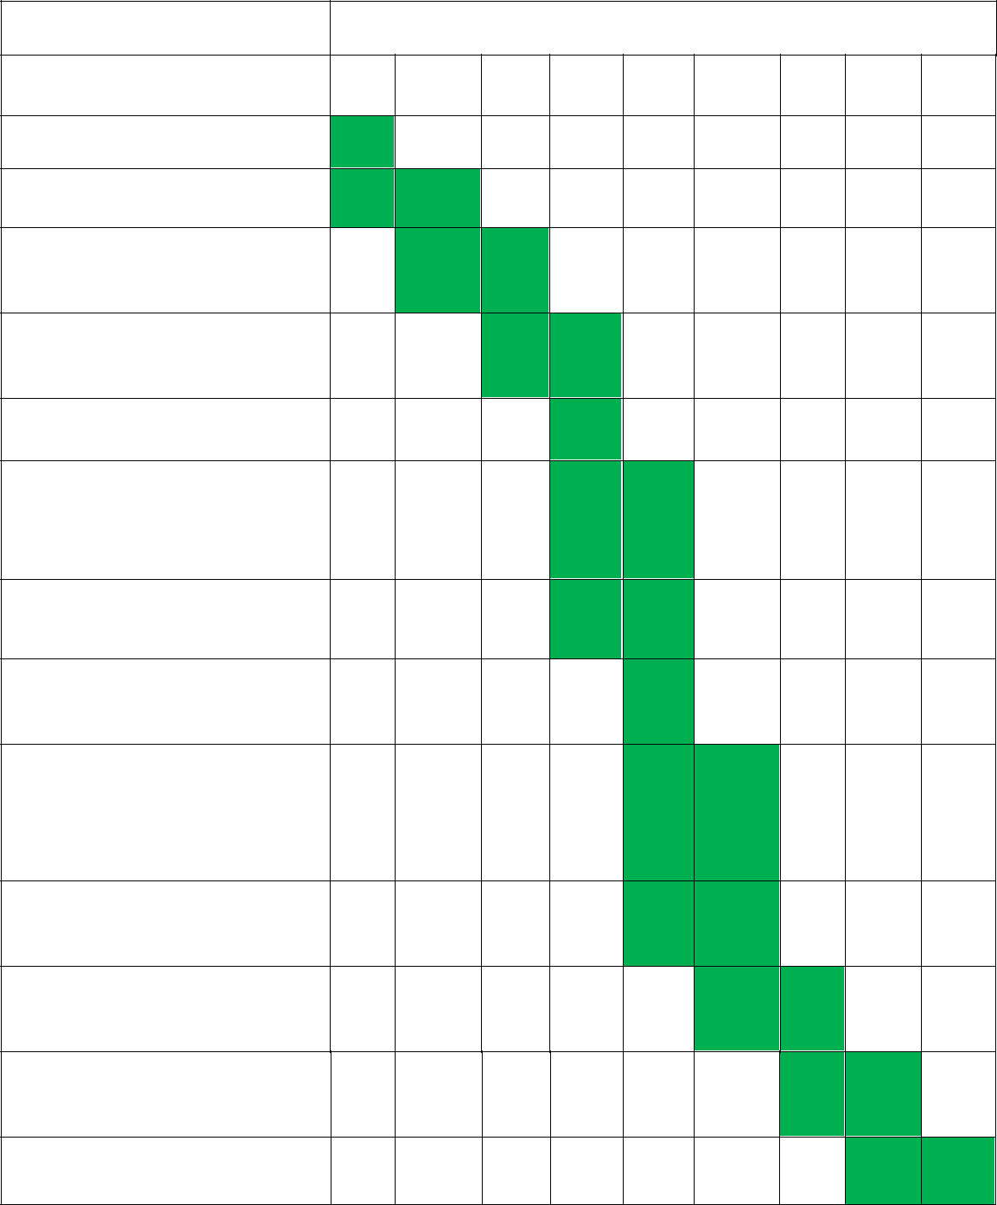**MONTHS**

|  |  |  |
| --- | --- | --- |
| July Aug. | Sep. Oct. Nov. Dec. | Jan. Feb. Mar. |

Theory

Review of Literature

Implementation of Photo,

Video capture

Implementation of Object

Detection offline and online

Storing Data to Databases

Machine Learning models for

speech to text, Google

Search, Traffic Sign Detection

FTP protocol implementation

Displaying data from

databases to web page

Implementation of TFT LCD/

display, Bluetooth speaker

Implementation of Google

Maps in Application

Implementation of playing

music via Bluetooth

Implementation of Text to

speech and vice versa

Final Prototype

**Appendix B: Project Summary**

|  |  |
| --- | --- |
| **Project Title** | **SMART WEARABLE TECHNOLOGY:SMART GLASS** |
| **Team Members** | Ayush Dev, Siddhant Pandey, Shubham Saxena, Sourav Das |
| **Faculty Guide** | Prof. (Dr.) Nirmal Kumar Rout |
| **Semester/Year** | VIII/IV year |
| **Project Abstract** | Studies on developing smart wearable technology are taking its boom in recent years making efforts towards better human life. Prime examples of smart wearable technologies are ‘Smart Glasses’ and ‘Smart Watches’. The integration of smart wearables with human well- being is becoming reality these days. The proposed smart glass is aimed to increase efficiency, productivity, and interlinking computing devices into our everyday lives by presenting the important information directly in front of his/her eyes for example: navigation information/directions, presenting critical data in medical operative procedures, gaming controls etc. Smart-glasses are also becoming useful for visually and hearing-impaired people. For blinds, several solutions are already available but they lack some functionalities and ease of use. In this paper, an effort in this direction is made, to rectify those problems. |
| **List codes and standards that significantly affect our project** | * 802.11b/g/n HT40 Wi-Fi transceiver. * TensorFlow version 2.7 was used. * Android Studio 4.0 version was used. * Operating Temperature of ESP32 Cam is -20 °C to 85 °C. * Operating Temperature of OLED display -40°C to 70°C. * ESP32 supports SD card upto 16GB. * Maximum Input Voltage to ESP32 is 3.6V. * Voltage Range forMAX30100 is 1.8 to 5.5V. |
| **List at least two**  **significant realistic**  **design constraints that are applied to our project** | * For the working of machine learning model the mobile phone has to be accompanied with the user. * For some features to work properly internet connection has to be present. * Sometimes the latency for image and video processing maybe high depending on internet connection and file size. |
| **Briefly explain two significant trade-offs considered in our design, including options considered and**  **the solution chosen** | * Sometimes, User may feel discomfort by wearing glasses for longer period of times. The solution for this is that user should take breaks in regular intervals and mobile application will also warn about this. * In broad daylight sometime user may feel that the brightness of glass display is not enough. |
| **Describe the computing aspects, if any of our project. Specifically identifying hardware-software trade-offs, interfaces, and/or interactions** | * The Api’s and source code used is only compatible with Android Operating System. |
| **Culminating**  **Knowledge and**  **lifelong learning**  **experience** | * For this project knowledge from,   Analog Electronics *(EC 2019)*  Digital Electronics *(EC 2011)*  Microcontrollers and Microprocessors *(EC 2020)*  Digital Signal Processing *(EC 3007)*  Neural Networks and Machine Learning *(EC 3021)*  Internet of Things *(EC 3050)*  Data communication & Networking *(EC 3028)*  C/C++ *(CS 1093)*  Python  Core Java/J2ME  Data Structures and Algorithms *(CS 2001)*  subjects has been used. |